College Management System

Submit in partial fulfillment of the requirements for the
Award of the degree of bachelor of computer
Application

Guide by:- Submitted by:-

Mr.Dinesh kumar ARYAN CHATURVEDI
(MCA)
Enroll no:-AT147133023



Submitted to
Makhanlal chaturvedi
National university of journalism vishwavidyalaya , Bhopal

STUDY CENTRE
Utkarsh Academy farrukhabad
(7133)

Self Certificate

This is to certify that this project entitled ’’Collage management Submitted in
Partial fulfillment of the degree of Bachelor of Computer Application to the
Makhanlal Chaturvedi National University of journalism
Bhopal is an authentic work carried out by her under my guidance

The matter embodied in this project work has not been submitted earlier for
Award of any degree or diploma to the best of my knowledge and belief.

Guide: - submitted by:-

Mr. Dinesh kumar ARYAN CHATURVEDI
(MCA)

Enroll No: AT147133023

STUDY CENTRE:
Utkarsh Academy farrukhabad(7133)

Preface

The six months training is an integral part of B.C.A. course curriculum
of MCRP University Bhopal, during the course of training
the training are expected use and apply their academic knowledge and
gain a valuable insight into corporate culture with all its environmental
and operational complexities.

The trainees offer a valuable opportunity to meet their academic
Knowledge with the real world situations. I undertook the training at
Utkarsh Academy farrukhabad.
During the course of training, I did comprehensive Study of various departments of the organization and their interrelationship.

As I am student of 6’th BCA, my focus was mainly directed towards
The development of good Project by using appropriate computer
Language/Package.

As result I came out with the project titled “ Collage management"
Using
VB.Net 2005 Technology at Utkarsh Academy farrukhabad.
.

Acknowledgement

Praise to God, the beneficial it is he no one else who has given us all the boundaries, which we see, in the world and given courage to complete this project. The project work in this report is an outcome of continual work over a period of SIX months and drew intellectual support from various sources. Obligations thus incurred in completing the work have been many. It is therefore almost impossible to express adequately the debts owed to many persons who have been instrumental in imparting this work a successful status. It is however matter of great pleasure to express my gratitude and appreciation to those who have been contributing to bring about this project. I take this opportunity to thanks
Mr Dinesh Gaur, Project Guider who has given me chance to work in development. Last but not least, my sincere thanks to my parents, who was directly or indirectly instrumental in enabling to accomplish the project successfully.

Date: Candidate:

ARYAN CHATURVEDI

Methodology of the report:

“software design technology is a system not secret”

Computer information system is developed to provided computer
Solution to user problems. If all the requirements of user are served by
The computerized solutions, the user are satisfied enough. Thus the
Software should be design effectively so as to meet its objective of user
Satisfaction.
Traditional development methodology called system development life
Cycle (SDLC) methodology, consist a set of development activities that
Have a prescribed order:
Once a problem or opportunity for a new system is recognized a
Request for developing a new system is forwarded for approval.

1. Preliminary survey / study:

This is the first step of system development life cycle. This phase is
Basically concerned about. Determining whether or not new system
Should be developed.

During this phase. Problem with the current system (manual or
Automated) are identified and also the benefits and cost of an
Alternative system is identified. If the benefits seem to outweigh
The cost approval is generated for new project development. Alter this
Is detailed plans and schedules are drafted for making the new
System a reality. Information should be gathered from many
sources. User must be interviewed to find out what exactly they
expect from the system. Organization current capabilities and
Operations must be clearly understood so as to use as inputs to the
System.
External information current is also critical for determining what
New system is available for providing specific types of output.

2. Feasibility study

At the end of information gathering phases, we have
An idea of the data available currently and the deficiencies of the current system. We also come to know the requirement and priorities. It is necessary to quantity the goal and objectives and at hat cost they are achieved.

In the development present system, no such restriction or limitation (RESOURSE AVAILABILITY) are imposed that where not feasible it is supposed that the resource are infinite and time is enough.

FESIBILITY STUDY CAN BE DEVIDED INTO THREE AREAS

1. economical feasibility
2.technical feasibility
3. oration feasibility

- Economical feasibility:

Economical feasibility analyses is done in order to ensure that the system ecnomicaly visibly. it is done in order to get an idea that it is possible to devlop the system within the organization financial limit.

A cost and basify analysis is necessary to determine economic
Feasibility. The primary objective of cost and benefit analysis is to find out whether it is economical feasible to invest the project. Comparing these two gives an argument either in favor of system or against the proposed system.

Cost of both direct and indirect types is considered. Direct cost are those incurred in buying equipment employing people cost of consumable items, rent for accommodation for system developers. ETC

Indirect cost involves brain storming time spent by user in
Discussing problem with the system analyst efforts in gathering data. ETC

(b) Technical feasibility analysis:

During technical feasibility analysis, the analyst evaluates the technical merit of the system concept; while at the same time at collect the information about the performance (system throughout) turnaround time etc.

Technical feasibility analysis begins with an assessment of the technical visibility of the proposed system. It is analyzed that what kind of environment, processed and methods are required to accomplish system.

A general logical model is prepared which resemble to the real world and show the various component and role in the system.

(c) Operational Feasibility analysis:

Operational feasibility analysis is done with an objective of finding the impact of the system on management and employee in organizations if the system is operationally feasible the management and user (employee) both welcome the proposal the development of new system an operational feasible system requires:

1. Minimum paper work
2. More users friendly
3. Reduced transaction time
4. Improvisation of report
5. Mental peace of employee

- Cost benefits analysis

To carry out and economic feasibility study, it is necessary to place money values agilest any purchases or activities needed to implement the project.
It is also necessary to place money values against any benefit that will accrue
from a new system created by the project such calculation are often described as benefit analysis cost-benefit analysis usually include two steps:

- producing the esthetes of costs and benefit and
- Determining whether the project is worthwhile once these costs are ascertained.
These may be things like selecting an alternative that matches , skill with the organization or perhaps , choosing a site for expansion that has been ignored for some time that can best utilities underused resources of an organization there by reducing the cost. Of solution

2. System analyses

It involves study of present system whether it is manual or computerized. If it is computerized then what are the loopholes of the present system and if it is not, some of the point involves in the system analyses are as following:

1. If the current system is computerized then why want the change in system.

2. What are the various jobs performed by the system.

3. If the present system is manual then is it feasible to make it computerized?

System study is done in to the organization it self taking various information, from different level of organization. It involved study of current system. the current system of hand ling employee detail is manually right from addition of new employee up to generations of report the complete process involves large no of employee from button peon level to middle level managers for processing a particular recorded the system has to pass through various files regarding the employee information, this system is being respective vet in nature, involves lot of time and man power this result in inconsistency and redudanancy
System analyses are concluded to archive the following objective:

4. Goal and objectives of the proposed system
5 .fundamental actions that must that must take place in the software
6. Output to be use
7. Process to be perform
8. Interface to be provided

9. Performance requirement to be met

10. Organization and other constraints to be met

3. System design

The phase is most creative and challenging phase of SDLC
This phase is concerned with the design of final system:

In this phase, firstly the output is design keeping in mind how the output is to be produced and in what format?

Secondly input data and files are designed to meet the requirement of the proposed output. The processing design involves program construction and testing finally, details of the entire designing, system justification details, and estimated impact on the user and.

Organization are documented and ovulated by management as step toward implementation.

4. implementation, maintenance, review

These are implemented, evaluation and maintenance begin. Like any system design. Implementation phase is mainly concerned with user training, site preparation and file conversion it also involves final testing of the system.

Once the system is implemented, evolution and maintenance
begin. Like any system there is an ageing process that requires
periodic eminence of hardware and software.
If the new system is inconsistent with the design specification, the

change has to be made Hardware also requires periodic
Maintenance to keep in tune with design specification.

5. system testing

A proper testing plan is necessary for the system before the implementation it greatly reduces the post implementation problem and also gives some ideas to the user if he is involved in this activity.
Testing present an interesting anomaly for the software engineer during earlier definition and development fazes the engineer attempts to build software from an abstract.

TESTING OBJECTIVE

- testing is a process of execution program with the intent of finding an error:
- Good test case is one that has a high probability of finding an error as yet undiscovered.
- A successful test is one uncovers a yet undiscovered error if a testing is conducted successfully, it will uncover error in the software. As a secondary benefit testing testing demonstrates that software.

TESTING PLAN
Following aspects were checked

- INTEGRITY TESTS
- SYSTEM TEST
- WHITE BOX TESTS
- BLOCK BOX TESTS
- SECURITY TESTS

INTEGRITY TEST:

From integrity tests total chain was executed and the result where compared against the actual result following chain were checked.

SYSTEM TEST:

System tested for some purchase and the result will be compared with tests calculated by the system all the test was carried out properly.

WHITE BOX TESTS

Step by step testing of coding designing in this test we can derive test cases:

- Guarantee that all independent paths within a module have been exercised at last one.
- Exercise all logical decision on their true and false sides.
- Execute all loops at there boundaries and within their operational bounds.
- Exercise internal data structure to ensure their validity.

BLOCK BOX TESTS:

System was tested for entering input and checks all the output which is generated by system in this test we can derives.

- incorrect or missing function
- interface errors
- error in data structure or external database access
- behavior or performance errors
- initialization and termination errors

SECURITY TEST:

To avoid information from being used by people. Who should not see it?
Two level checks are provided in the application design.

Window programming environment

Since the introduction of windows programming environment there have been major changes in the way pc programs looks. The way they work and the way they are written.

Computer has given us the power to think in a fundamentally non-linear fashion for example the ability to cut and past has allowed us to create objects at random and to organize our randomness at a later time at the state of computing matured. User begins to see through the simple miracles of cut and paste operations lightening speed calculation and random access organization they wanted program that where visually appealing and intuitive to us. Today we feel the consequence all around us that any program that does not have a GUI looks primitive.
For the user window provides a multitasking, graphical based windowing environment that runs program especially designed for windows. Such program include ms-excel, ms-word and many other. Programs written for windows have a consistence appearance and command structure and are thus often easier to learn and use then conventional program. User can easily switch among different windows programs and exchange data between them. Windows also provides an easy to use icon based program manager for maintenance and printer queue management.

Graphical user interface

Windows provides considerable advantage to both user and programmer over the conventional ms dos averment the benefits to user and the benefits to program developer are to give user what they need and want windows makes possible. It is true that the graphical user interface is now the single most important “grand consensus of the personal computer industry although the various graphical environment differ in details, they haze
Similar characteristics.

Data Dictionary

Data dictionary formally describes the system data and where they are used.
All definition of the elements in the system are described in detail in the system are described in the detail in the data dictionary.
The data dictionary is a reference work of data compiled by the analyst. To guide them through analysis and design.

It is an organized listing of all data element that are pertinent to the system with precise, regress definitions so that both the user and the developer have a common understanding of all the component of the program.

CONTENTS

1 => Project introduction:
► Acknowledgement
► Self Certificate
► Preface
► Introduction
2 => About Logia InfoTech:
► Services
► Training
► Consolation
► Product
► Business Overview
3 => The University
4=> Documentation:
►Salient feature of the Project:
► Problems faced in the Project:
► Objective and Scope
7 => Methodology of the Report:
► Preliminary survey/ study
► Feasibility study
► Testing
► Maintenance
8 => Implementation Specification:
► Software used
► h/w used
9 => Theoretical background:
► .Net Framework
► VB.Net
► Data accessing tools
► MS access 2003 Features
► SQL
10 => Detailed Life Cycle
► SDLC
► Flow Chart
► E-R Diagram
► Data dictionary
11=> Form Design:
12=> Source code:
13=> Bibliography:

Visual basic .Net

Introduction:

Visual basic is the most popular programming tool available today and it’s also secret that there have been massing changes in it as it becomes visual basic .net.

Version 4.0 was a big change unsettling many programming, but the changes from vb6 to vb.net are far biggest. The latest version of Microsoft’s visual studio, called visual studio.net, include visual basic, visual c++, c# and .net framework.
Microsoft visual basic .net comes with visual basic .net.

VB.NET: Visual Basic.NET is released shortly after the 10’Tanniversaryof the first version of VB. the original language that change the landscape
Of computing has lasted ten years and has enabled torero grimmest write window application than any language. Programmers who invested in VB ten year ago in demand today. In the world of computing, however thing changes very fast, including languages. At some point, they either die or they evolve into something new. Visual basic was a language designed primarily for developing windows application. It was simple language, because it manages to hide many of the low level details of the operating system. Those who wanted to do more with visual Basic had to resort to windows API. In a way earlier version of VB was send box to protect developers from scary details. Microsoft had to redesign VB. The old language just did not belong in the .NET (At least it would not integrate very well into the picture) VB.NET is not VB7; it is a drastic departure. VB.NET was designed to take us thought the next decade of computing and if you want to stay ahead, you will have to invest the time and effort to learn it. The most fundamental component of the .NET initiative is the .NET framework; or simply the framework. You can think of the framework as an enormous collection of function for just about any programming task. All drawing method is part of the SYSTEM.DRAWING class.

This programming language in visual studio .net run in new .net framework provide for easiest development of web based and window based application; allow object from different language to operate together.

The .net language all compile to (are translated to) a common machine language, called Microsoft intermediate language (MSIL)

The MSIL code called managed code runs common language runtime (CLR)

GRAPHICAL USER INTERFACE:-

Windows provides considerable advantage to both user and programmers over the conventional MS-DOS environment.
The benefits to users and the benefits to program developer are to give users what they need and want. Windows makes this possible. It is true that the graphical Users Interface is now the single most important “grant consensus” of the personal computer industry. Although the various graphical environments differ in details, they have similar characteristics

GUI CONCEPT AND RATIONALE:-

All graphical user interfaces make use of graphics on a bit mapped video display. Graphical provides better utilization of screen real estate. Visually rich environment for conveying information, and the possibility of a WAY/WYG (what you see is what you get) video of graphics and formatted text prepared for a printed document.

In earlier day, the video display was use solely to echo text that the user typed using the keyboard. In Graphical User Interface, the video display it self becomes a source of user input. The video displays show various graphical objects of the form of icons and input devices such as a buttons and scroll bar.
Although Windows exists primarily to run application especially written for its environment, window can also run many programs written for MS-DOS. One of the first things users notice as a windows user is how easy it is to use the consistent, graphical interface. Windows gets data from the users in a special window called a dialog box.

Dialog boxes use special window called control windows that let user inter text, choose from a list or options. The control and format of a dialog box are stored in a file called resources file that is attached to the executable file.

WHAT IS DATA BASE

To a beginner the term database may sound too technical or complicated but I am sure, that once you understand the concept behind this term, you will discover that it is very simple let us first describe what a database is. It has been define in several ways, a simple definition would be. “The data base is an organized collection of related information (DATA)” Here the stress is on the organized.

The organized information or the database server as a base from which a desired information can be retrieved many meaningful conclusion can be drew, or decision made by further re-organization or processing this data.

Even if you did not know what a database is, I m sure you must have used a database in your day-to-day life. The dictionary is one of the most common examples of database, where words are arranged alphabetically.

The telephone directory is another example of a database, where the of the telephone the subscribers are given in alphabetically, we come across various other kinds of database of the manes, addresses, salaries, allowances and deductions etc. for the employees: a magazine publisher may have a database of subscribers: the stores department of a factory has a database of the items available in the stores and a public limited company has a database of its shareholders,
Most of you keep a list of the address of our friends and relatives, which is usually written down in addresses. You also perform several operations on your database.

If a person from your database moves to anew location, you have to change his/her address in your address book- this is called editing information in database you also add new address in your have to send a latter to someone, you look into that book to find the address (search in database).if the list grows to even a hundred address, finding out a particular address may become cumbersome.

So you usually classify the addresses based on the initial/surname of the person and allot different pages for names beginning with different letters. In this way you try to manage, your address list database in a batter way.

Determine the fields you need

Each table contains information's about the same
subjects, and each field in a table contains
'individual facts about than tables' subject.
For example, a customer table may include
company name, address, city, state, and phone
number fields. When sketching out the fields
for each table, keep these tips in mind :

Relate each field directly to the subject of the table.
Don't include derived or calculated data (data that is
the result of an expression).

include all the information you need.
Store information in its smallest logical parts
for example, First and Last Name,
rather than Name).

Identify fields with unique values

In order for Microsoft Access to connect
information stored in separate tables 3/4 for
example, to connect a customer with all the
customer's orders 3/4 each table in your database
must include a field or set of fields that's uniquely
identifies each individual recorded in the table.
Such a field is called a primary key.

For information on primary keys, and for help in
Determining the types of keys to use of your tables,

DETERMINE THE RELATIONSHIPS BETWEEN TABLES

Now that you've divided your information's in to
tables and identified primary key fields, you
need a way to tell Microsoft Access how to
bring related information back together
again in meaningful ways. To do this, you
define relationships between tables.

You May find it useful to view the relationships
in an existing well-designed database. To see the relationships
in the North wind sample database,
open Northwind.mdb and click Relationships on
the tools menu. For information on the
types of relationships, and for help in
determining the relationships for your
database, click For more information
on opening North wind, click.

Refine the design

After you have designed the tables, fields, and
relationships you need, it's time to study the design and
detect any flaws
that might reaming. It is easier to change your database
design now, rather than after you have filled the tables
with data.

Use Microsoft Access to create your tables, specify
relationships between the tables, and enter a few records
of data in each table. See I you can use the database to
get the answers you want. Create rough drafts of your
forms and reports and see if they show the data
you expect. Look for unnecessary duplications
of data and criminate them.

Enter data and create other database objects

When you are satisfied that the table structures
meet the design goals described here,
then it's time to go ahead and all you existing
PSEUDO CODE AND CODINGS STANDARD

CODING STANDARS:-

Coding standards is specific form a development firm. Each company is having its coding standards as suitable to the employees and environment. So there are hard coded rules for deciding coding standards as it depends on the methodology of company. Coding standards are adopted to make the coding style consistent and understanding for any of the person who belongs to that firm. These coding standards provide an easy way to grasp the substance of code in a quick time. As coding standard are specific for a particular company or firm, the programmer working there are at home even with other programmer’s code as the conventions are same which enables an easy to debug code as the programmer knows where the different bugs can occur as convention enables him to look in the right direction.

CODING STANDARS OPTED:-

Database was designed by making scripts. These scripts were written in SQL and there were specific standards for designed that scripts:

- Each scripts was required to have the name of the script, date of creation, purpose of creation, the author of the script, and last modification date.

- The SQL keywords were to be written in CAPS where as user defined name and variables were written in case. for ex, in the statement SELECT * FROM imp; here SELECT and form are reserved SQL words therefore they are written in CAPS whereas the user defined name “imp” is in lower case .

  - As soon as a particular form is loaded, the focus should be on the view button.

  - For any information to be retrieved through a combo box search criteria should be given in alphabetical way and the combo box should open instantly with the item to be searched show in highlight.

  - The naming convention adopted for different controls are.

PSEUDO CODE:-

Pseudo code is written to prepare logic for a program it is a language independent piece of instruction, which guides a programmer to write a computer program for the logic. by looking at the pseudo code, any person who has knowledge of the computer program The following are the advantages for writing a pseudo code:

- As it is language independent, even a non technical person can prepare it.

- There is no syntax constraints so a programmer has not to fall in trap of syntax errors and can concentrate wholly on preparing the login for a particular purpose.

- One the pseudo code is ready, the computer program can be written instantly as just the logic needs to be transformed into the syntax.

- A better approach to programming can be achieved.

Design documentation. At their lowest level of detail, as we shall see, Dads are often include in a programmers working specification when the system analysis is complete and the system is being.

Why the data flow diagram? In Dutch there’s an expression:’ n baling jest Mere Dan distend wooden; (one view say more then a thousand word). this also truth for a graphical description, model . It’s difficult, if not impossible, to describe a model in words and still being clear and not complex. This was one the main reason to develop a graphical modeling technique like data flow diagram.
There are certain number was data flow diagram can be represented.

Data flow diagram usually are made after a context diagram has been made, because the data context diagram function as the basis of a data flow diagram. It’s important not to forget that data flow diagram are not a model of flow of control or sequence of processing in a system. Data flow diagrams must be seen as model, which show the flow of data through a system.

External entry | Source or destination of data that is external to the system.
Process | Manual or computer process that change data.
Data flow | Data transfer in the direction include by the arrow. Each arrow should be labeled to include what data is being transferred.
Data store | Manual are computer storage of data.

Form Design

Flowchart symbols

Symbols:-

=> Process

=> Input/output

=> Decision box

=> Start/End

= > Direction Flow

MAINTENANCE

Maintenance includes the modification of existing application to correct errors and bugs. Improve the performance or even adapt to a changed environment. The service can be extended to include change requests from clients dealing with enhancements and refinements. As part of the services the responsibility is keeping applications reliable and available on a continuous basis. This eases the key challenge of running existing application, providing code maintenance and performance management. The maintenance model used for this service consists of the following phases and activities:

Identify Maintenance Boundary:

1. Understand System
2. Agree Maintenance Terms

Set-up offsite Maintenance Center:

1. Set-up Maintenance Environment
2. Trained Team

Service Maintenance Request:

1. Evaluate Maintenance Request
2. Develop Code
3. Maintenance Test
4. Regression Test

Co-ordinate Maintenance:

1. Raise Maintenance Request
2. Acceptance Test
3. Deploy Modification

Form Design

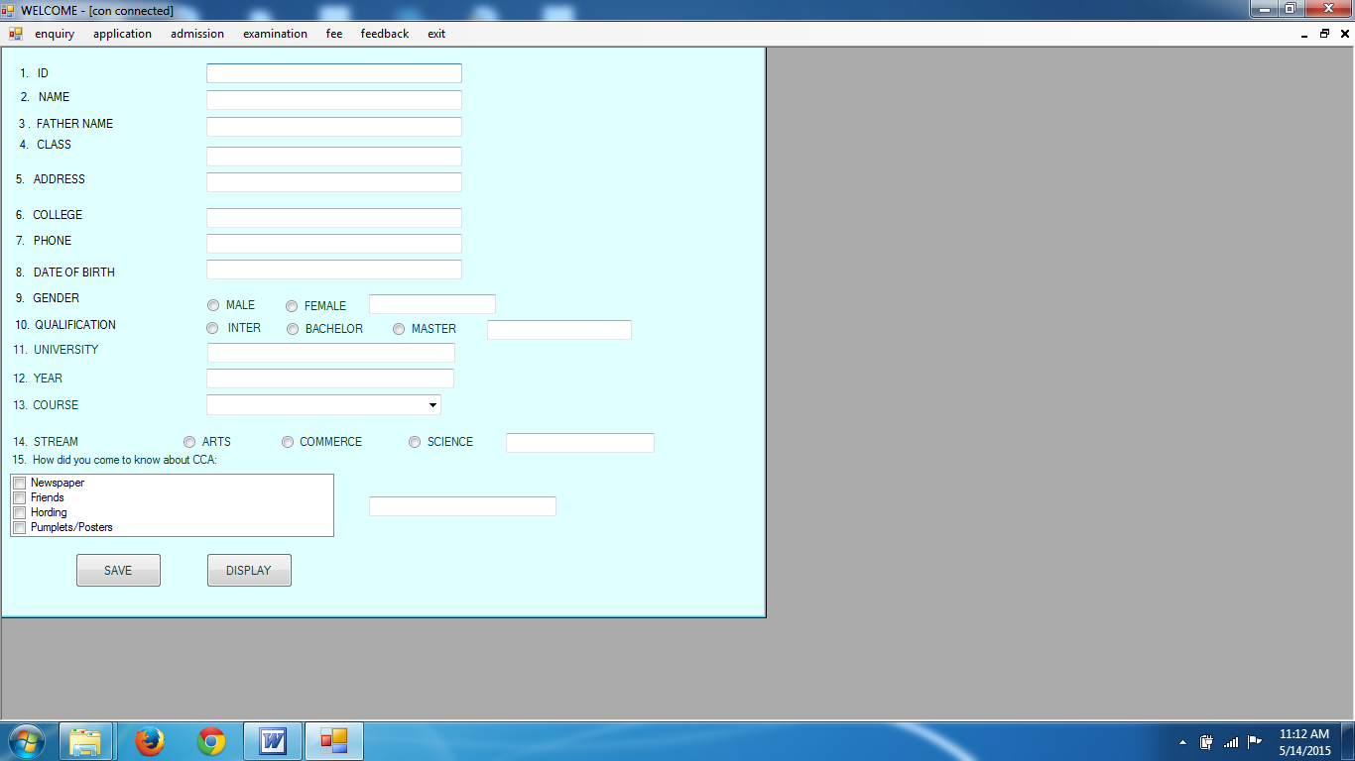

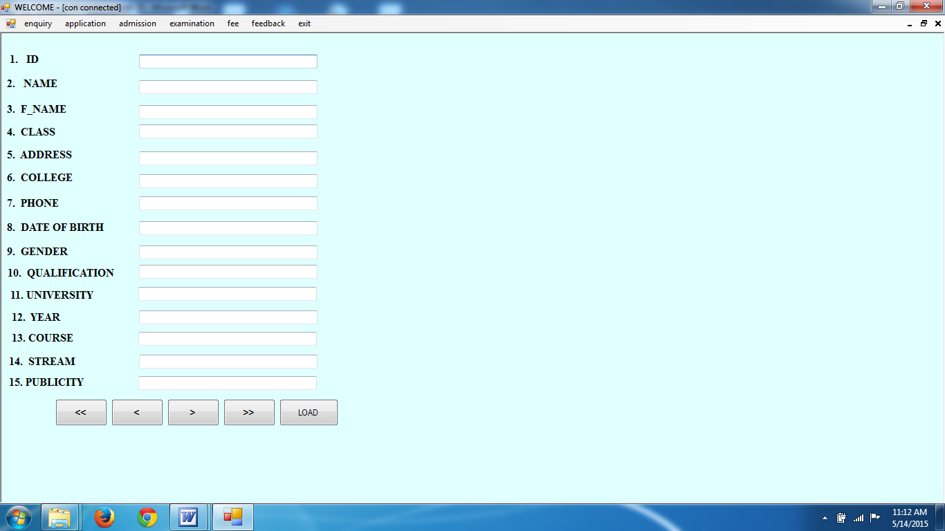

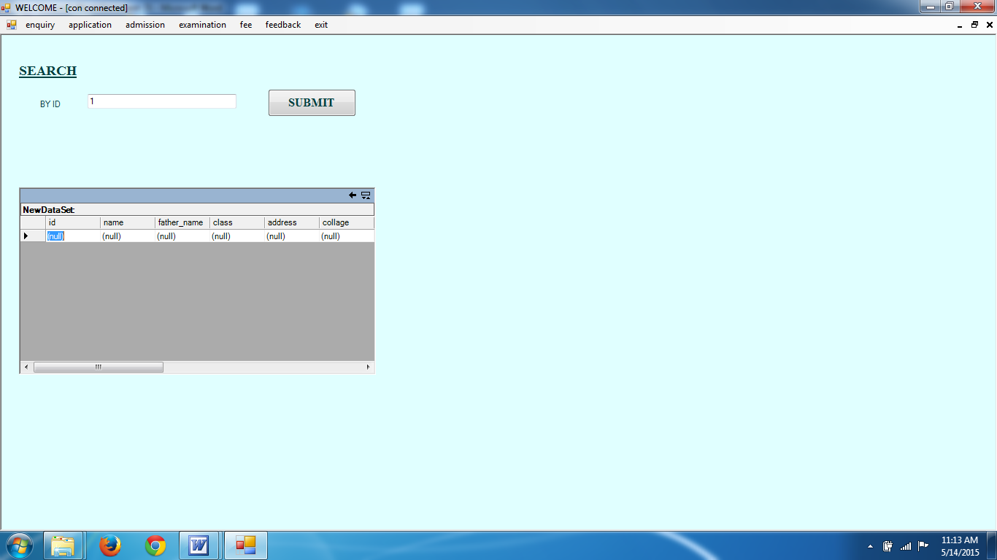

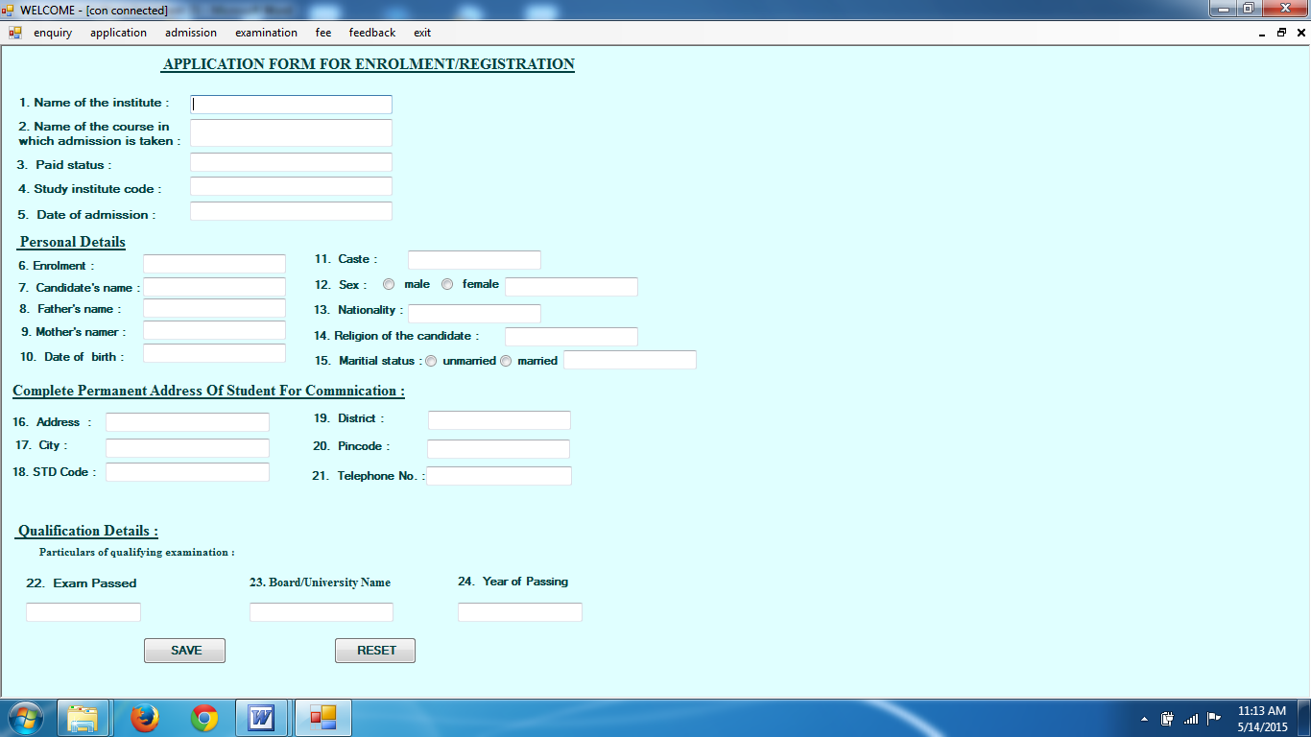

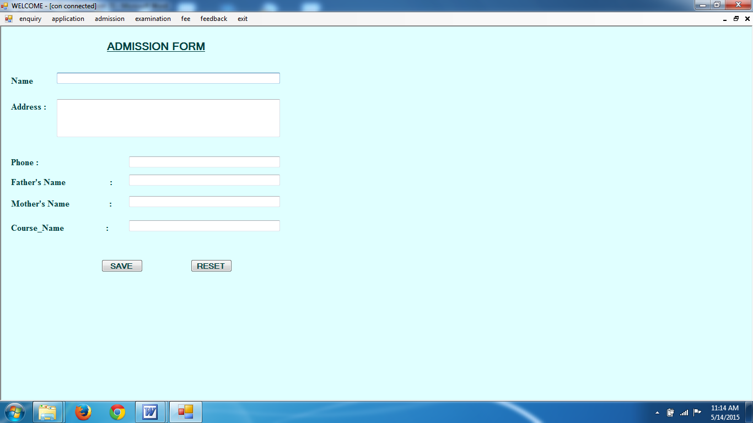

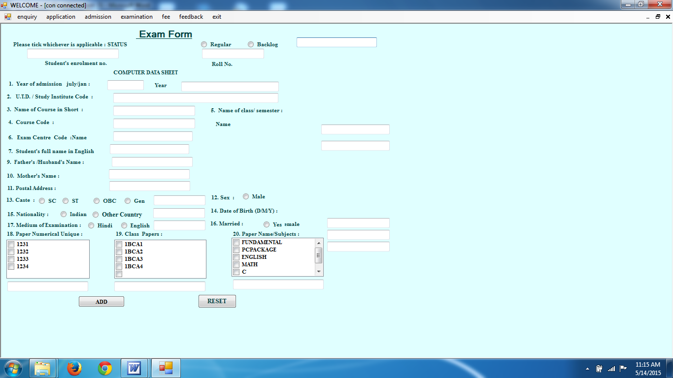

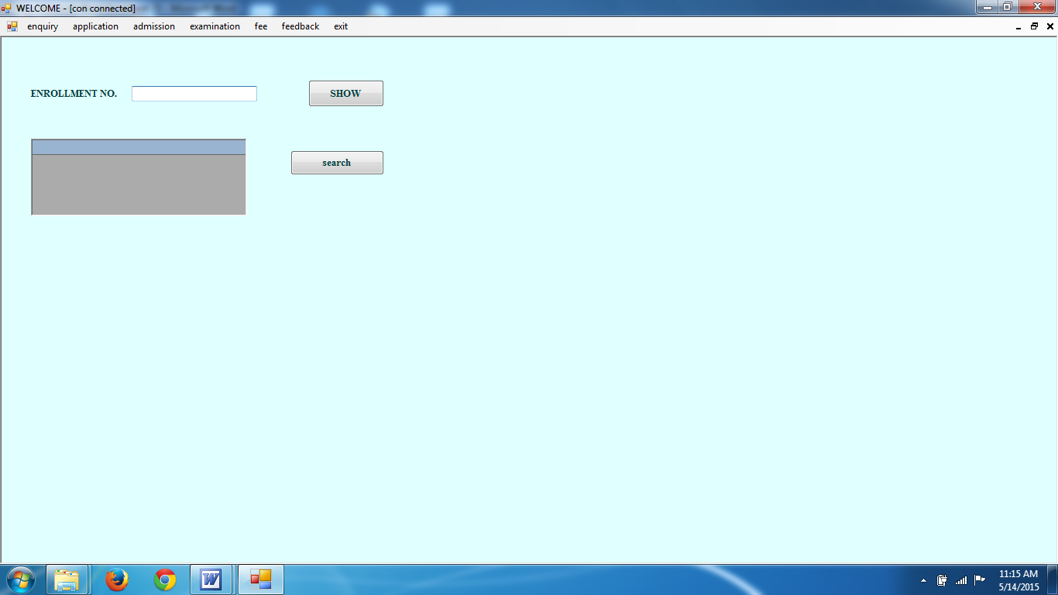

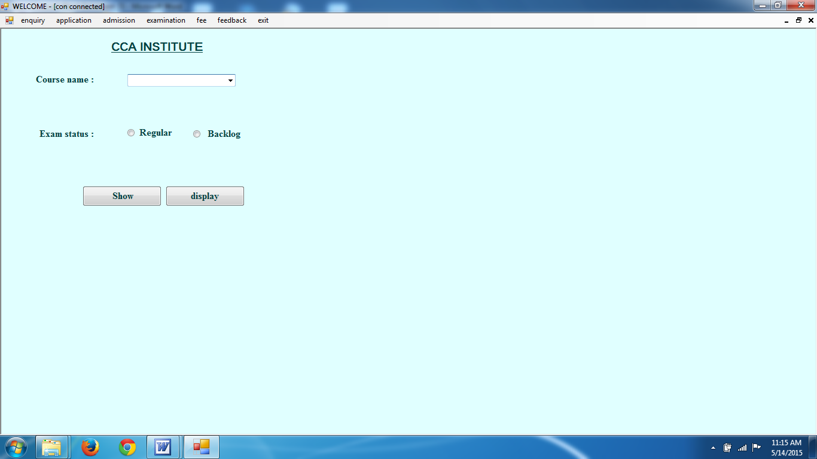

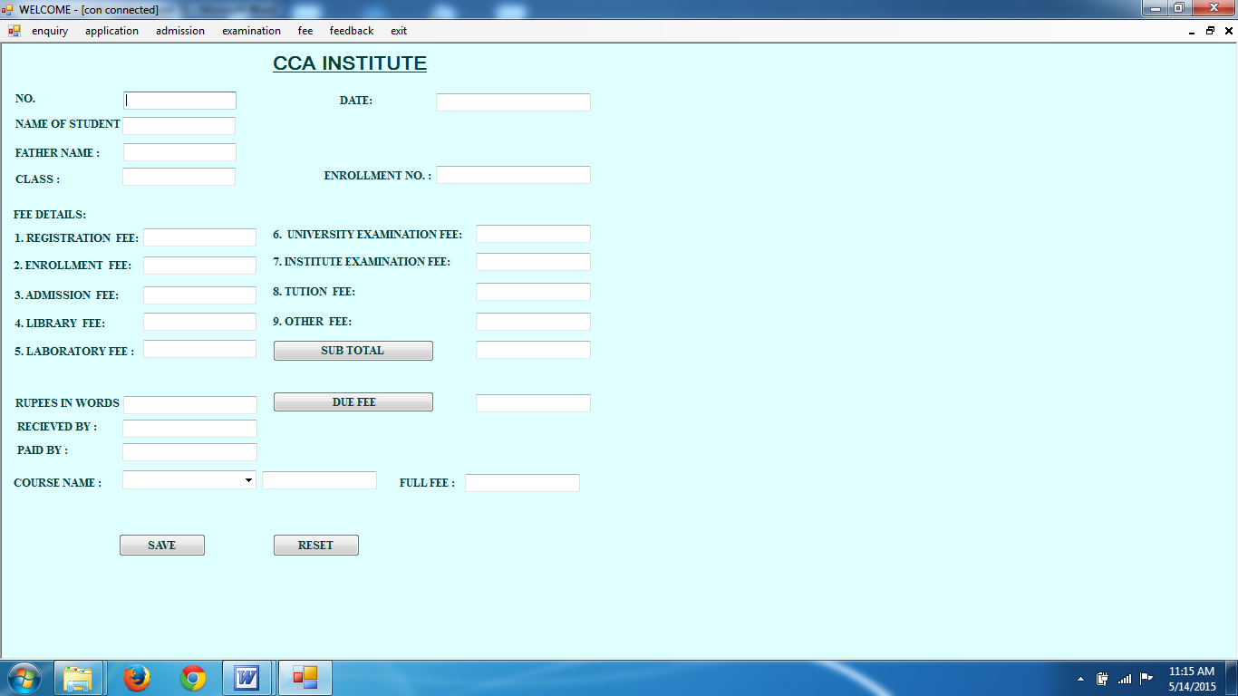

Form Code

Public Class Form1

Private Sub Form1_Load(ByVal sender As System.Object, ByVal e As System.EventArgs) Handles MyBase.Load

PB1.Width = Me.Width - 20
PB1.Top = Me.Height - 75
Label5.Top = Me.Height - 150
PB1.Left = 10
Button1.Visible = False

Timer1.Enabled = True
End Sub

Private Sub Timer1_Tick(ByVal sender As System.Object, ByVal e As System.EventArgs) Handles Timer1.Tick
PB1.Value = PB1.Value + 1
Label5.Text = PB1.Value + 1 & " % completed"
If PB1.Value >= 99 Then
Timer1.Enabled = False
MsgBox("welcome to our project", MsgBoxStyle.DefaultButton1)
Button1.Visible = True

End If
End Sub

Private Sub Button1_Click(ByVal sender As System.Object, ByVal e As System.EventArgs) Handles Button1.Click
Dim f2 As New Form2
f2.Show()
End Sub

End Class

Public Class Form2

Private Sub EntryToolStripMenuItem_Click(ByVal sender As System.Object, ByVal e As System.EventArgs) Handles EntryToolStripMenuItem.Click
Dim f3 As New Form3
f3.Show()
f3.MdiParent = Me
End Sub

Private Sub DisplayToolStripMenuItem_Click(ByVal sender As System.Object, ByVal e As System.EventArgs) Handles DisplayToolStripMenuItem.Click
Dim f4 As New Form4
f4.Show()
f4.MdiParent = Me
End Sub

Private Sub SearchToolStripMenuItem_Click(ByVal sender As System.Object, ByVal e As System.EventArgs) Handles SearchToolStripMenuItem.Click
Dim f5 As New Form5
f5.Show()
f5.MdiParent = Me
End Sub

Private Sub ExaminationToolStripMenuItem_Click(ByVal sender As System.Object, ByVal e As System.EventArgs) Handles ExaminationToolStripMenuItem.Click

End Sub

Private Sub EntryToolStripMenuItem1_Click(ByVal sender As System.Object, ByVal e As System.EventArgs) Handles EntryToolStripMenuItem1.Click

Dim f9 As New Form9
f9.Show()
f9.MdiParent = Me
End Sub

Private Sub DisplayToolStripMenuItem1_Click(ByVal sender As System.Object, ByVal e As System.EventArgs) Handles DisplayToolStripMenuItem1.Click
Dim f10 As New Form10
f10.Show()
f10.MdiParent = Me
End Sub

Private Sub SearchToolStripMenuItem1_Click(ByVal sender As System.Object, ByVal e As System.EventArgs) Handles SearchToolStripMenuItem1.Click
Dim f11 As New Form11
f11.Show()
f11.MdiParent = Me
End Sub

Private Sub EntryToolStripMenuItem2_Click(ByVal sender As System.Object, ByVal e As System.EventArgs) Handles EntryToolStripMenuItem2.Click

Dim f6 As New Form6
f6.Show()
f6.MdiParent = Me

End Sub

Private Sub DisplyToolStripMenuItem_Click(ByVal sender As System.Object, ByVal e As System.EventArgs) Handles DisplyToolStripMenuItem.Click

Dim f7 As New Form7
f7.Show()
f7.MdiParent = Me

End Sub

Private Sub SearchToolStripMenuItem2_Click(ByVal sender As System.Object, ByVal e As System.EventArgs) Handles SearchToolStripMenuItem2.Click
Dim f8 As New Form8
f8.Show()
f8.MdiParent = Me

End Sub

Private Sub HelpToolStripMenuItem_Click(ByVal sender As System.Object, ByVal e As System.EventArgs) Handles HelpToolStripMenuItem.Click

End Sub

Private rchToolStripMenuItem.Click
Dim f13 As New Form13
f13.Show()
f13.MdiParent = Me
End Sub

Private Sub ExamdetailToolStripMenuItem_Click(ByVal sender As System.Object, ByVal e As System.EventArgs) Handles ExamdetailToolStripMenuItem.Click
Dim f14 As New Form14
f14.Show()
f14.MdiParent = Me
End Sub

Private Sub ExitToolStripMenuItem1_Click(ByVal sender As System.Object, ByVal e As System.EventArgs) Handles ExitToolStripMenuItem1.Click
Me.Close()
End Sub

Private Sub FEEDISPLAYoolStripMenuItem_Click(ByVal sender As System.Object, ByVal e As System.EventArgs) Handles FEESEARCHToolStripMenuItem.Click
Dim f20 As New Form20
f20.Show()
f20.MdiParent = Me
End Sub

Private Sub FEEENTRYToolStripMenuItem_Click(ByVal sender As System.Object, ByVal e As System.EventArgs) Handles FEEDISPLAYToolStripMenuItem.Click
Dim f18 As New form18
f18.Show()
f18.MdiParent = Me
End Sub

Private Sub FEESEARCHToolStripMenuItem1_Click(ByVal sender As System.Object, ByVal e As System.EventArgs) Handles FEESEARCHToolStripMenuItem1.Click
Dim f21 As New Form21
f21.Show()
f21.MdiParent = Me
End Sub

Private Sub ComplaintformToolStripMenuItem_Click(ByVal sender As System.Object, ByVal e As System.EventArgs) Handles ComplaintformToolStripMenuItem.Click
Dim f17 As New Form17
f17.Show()
f17.MdiParent = Me
End Sub

Private Sub DisplayToolStripMenuItem2_Click(ByVal sender As System.Object, ByVal e As System.EventArgs) Handles DisplayToolStripMenuItem2.Click
Dim f19 As New Form19
f19.Show()
f19.MdiParent = Me
End Sub
End Class

Imports System.Data
Imports System.Data.OleDb

Public Class Form3
Dim con As New OleDbConnection
Dim cmd As New OleDbCommand

Private Sub Form3_Load(ByVal sender As System.Object, ByVal e As System.EventArgs) Handles MyBase.Load
con.ConnectionString = "provider = microsoft.jet.oledb.4.0; data source = inst_mgt.mdb"
con.Open()
Me.Text = "con connected"
End Sub

Private Sub Button1_Click_1(ByVal sender As System.Object, ByVal e As System.EventArgs) Handles Button1.Click
cmd.CommandText = "insert into inq_det values (" & Val(TextBox1.Text) & ", '" & TextBox2.Text & "' , '" & TextBox3.Text & " ' , ' " & TextBox4.Text & " ','" & TextBox5.Text & "','" & TextBox6.Text & "','" & TextBox7.Text & "','" & TextBox8.Text & "','" & TextBox9.Text & "','" & TextBox10.Text & "','" & TextBox11.Text & "','" & TextBox12.Text & "','" & ComboBox1.Text & "','" & TextBox13.Text & "','" & TextBox14.Text & "')"
cmd.Connection = con
cmd.ExecuteNonQuery()
MsgBox("record inserted")
con.Close()
End Sub

Private Sub RadioButton1_CheckedChanged(ByVal sender As System.Object, ByVal e As System.EventArgs) Handles RadioButton1.CheckedChanged
If Me.RadioButton1.Checked = True Then
Me.TextBox9.Text = Me.RadioButton1.Text

End If
End Sub

Private Sub RadioButton2_CheckedChanged(ByVal sender As System.Object, ByVal e As System.EventArgs) Handles RadioButton2.CheckedChanged

If Me.RadioButton2.Checked = True Then
Me.TextBox9.Text = Me.RadioButton2.Text
End If
End Sub

Private Sub RadioButton3_CheckedChanged(ByVal sender As System.Object, ByVal e As System.EventArgs) Handles RadioButton3.CheckedChanged
If Me.RadioButton3.Checked = True Then
Me.TextBox13.Text = Me.RadioButton3.Text
End If

End Sub

Private Sub RadioButton4_CheckedChanged(ByVal sender As System.Object, ByVal e As System.EventArgs) Handles RadioButton4.CheckedChanged
If Me.RadioButton4.Checked = True Then
Me.TextBox13.Text = Me.RadioButton4.Text
End If
End Sub

Private Sub RadioButton5_CheckedChanged(ByVal sender As System.Object, ByVal e As System.EventArgs) Handles RadioButton5.CheckedChanged
If Me.RadioButton5.Checked = True Then
Me.TextBox13.Text = Me.RadioButton5.Text
End If
End Sub

Private Sub RadioButton6_CheckedChanged(ByVal sender As System.Object, ByVal e As System.EventArgs) Handles RadioButton6.CheckedChanged
If Me.RadioButton6.Checked = True Then
Me.TextBox10.Text = Me.RadioButton6.Text
End If
End Sub

Private Sub RadioButton7_CheckedChanged(ByVal sender As System.Object, ByVal e As System.EventArgs) Handles RadioButton7.CheckedChanged
If Me.RadioButton7.Checked = True Then
Me.TextBox10.Text = Me.RadioButton7.Text
End If
End Sub

Private Sub RadioButton8_CheckedChanged(ByVal sender As System.Object, ByVal e As System.EventArgs) Handles RadioButton8.CheckedChanged
If Me.RadioButton8.Checked = True Then
Me.TextBox10.Text = Me.RadioButton8.Text
End If
End Sub

Private Sub CheckedListBox1_SelectedIndexChanged(ByVal sender As System.Object, ByVal e As System.EventArgs) Handles CheckedListBox1.SelectedIndexChanged
Dim ST, ST1 As String
ST1 = " "
For Each ST In Me.CheckedListBox1.CheckedItems
ST1 &= ST & " , "

Next
TextBox14.Text = ST1
End Sub

Private Sub Button2_Click(ByVal sender As System.Object, ByVal e As System.EventArgs) Handles Button2.Click
Dim f4 As New Form4
f4.Show()

End Sub

End Class

Imports System.Data
Imports System.Data.OleDb
Public Class Form4
Dim con As New OleDbConnection
Dim cmd As OleDbCommand

Dim adp As New OleDbDataAdapter
Dim str As String
Dim i As Integer
Dim j As Integer
Dim ds As New DataSet

Private Sub Form4_Load(ByVal sender As System.Object, ByVal e As System.EventArgs) Handles MyBase.Load
con.ConnectionString = "provider = microsoft.jet.oledb.4.0; data source = inst_mgt.mdb"
con.Open()
Me.Text = "con connected"

str = "select * from inq_det"
cmd = New OleDbCommand(str, con)
adp.SelectCommand = cmd
adp.Fill(ds, "inq_det")
i = ds.Tables("inq_det").Rows.Count() - 1
j = i

End Sub

Private Sub Button5_Click(ByVal sender As System.Object, ByVal e As System.EventArgs) Handles Button5.Click
Me.Text = "FORM LOADED"
con.Close()

End Sub

Private Sub Button1_Click(ByVal sender As System.Object, ByVal e As System.EventArgs) Handles Button1.Click
i = 0
TextBox1.Text = ds.Tables("inq_det").Rows(i).Item(0)
TextBox2.Text = ds.Tables("inq_det").Rows(i).Item(1)
TextBox3.Text = ds.Tables("inq_det").Rows(i).Item(2)
TextBox4.Text = ds.Tables("inq_det").Rows(i).Item(3)
TextBox5.Text = ds.Tables("inq_det").Rows(i).Item(4)
TextBox6.Text = ds.Tables("inq_det").Rows(i).Item(5)
TextBox7.Text = ds.Tables("inq_det").Rows(i).Item(6)
TextBox8.Text = ds.Tables("inq_det").Rows(i).Item(7)
TextBox9.Text = ds.Tables("inq_det").Rows(i).Item(8)
TextBox10.Text = ds.Tables("inq_det").Rows(i).Item(9)
TextBox11.Text = ds.Tables("inq_det").Rows(i).Item(10)
TextBox12.Text = ds.Tables("inq_det").Rows(i).Item(11)
TextBox13.Text = ds.Tables("inq_det").Rows(i).Item(12)
TextBox14.Text = ds.Tables("inq_det").Rows(i).Item(13)
TextBox15.Text = ds.Tables("inq_det").Rows(i).Item(14)

End Sub

Private Sub Button4_Click(ByVal sender As System.Object, ByVal e As System.EventArgs) Handles Button4.Click
i = j
TextBox1.Text = ds.Tables("inq_det").Rows(i).Item(0)
TextBox2.Text = ds.Tables("inq_det").Rows(i).Item(1)
TextBox3.Text = ds.Tables("inq_det").Rows(i).Item(2)
TextBox4.Text = ds.Tables("inq_det").Rows(i).Item(3)
TextBox5.Text = ds.Tables("inq_det").Rows(i).Item(4)
TextBox6.Text = ds.Tables("inq_det").Rows(i).Item(5)
TextBox7.Text = ds.Tables("inq_det").Rows(i).Item(6)
TextBox8.Text = ds.Tables("inq_det").Rows(i).Item(7)
TextBox9.Text = ds.Tables("inq_det").Rows(i).Item(8)
TextBox10.Text = ds.Tables("inq_det").Rows(i).Item(9)
TextBox11.Text = ds.Tables("inq_det").Rows(i).Item(10)
TextBox12.Text = ds.Tables("inq_det").Rows(i).Item(11)
TextBox13.Text = ds.Tables("inq_det").Rows(i).Item(12)
TextBox14.Text = ds.Tables("inq_det").Rows(i).Item(13)
TextBox15.Text = ds.Tables("inq_det").Rows(i).Item(14)
End Sub

Private Sub Button2_Click(ByVal sender As System.Object, ByVal e As System.EventArgs) Handles Button2.Click
i = i - 1
If i < 0 Then
i = 0

End If

TextBox1.Text = ds.Tables("inq_det").Rows(i).Item(0)
TextBox2.Text = ds.Tables("inq_det").Rows(i).Item(1)
TextBox3.Text = ds.Tables("inq_det").Rows(i).Item(2)
TextBox4.Text = ds.Tables("inq_det").Rows(i).Item(3)
TextBox5.Text = ds.Tables("inq_det").Rows(i).Item(4)
TextBox6.Text = ds.Tables("inq_det").Rows(i).Item(5)
TextBox7.Text = ds.Tables("inq_det").Rows(i).Item(6)
TextBox8.Text = ds.Tables("inq_det").Rows(i).Item(7)
TextBox9.Text = ds.Tables("inq_det").Rows(i).Item(8)
TextBox10.Text = ds.Tables("inq_det").Rows(i).Item(9)
TextBox11.Text = ds.Tables("inq_det").Rows(i).Item(10)
TextBox12.Text = ds.Tables("inq_det").Rows(i).Item(11)
TextBox13.Text = ds.Tables("inq_det").Rows(i).Item(12)
TextBox14.Text = ds.Tables("inq_det").Rows(i).Item(13)
TextBox15.Text = ds.Tables("inq_det").Rows(i).Item(14)
End Sub

Private Sub Button3_Click(ByVal sender As System.Object, ByVal e As System.EventArgs) Handles Button3.Click
i = i + 1
If i > j Then
i = j
End If
TextBox1.Text = ds.Tables("inq_det").Rows(i).Item(0)
TextBox2.Text = ds.Tables("inq_det").Rows(i).Item(1)
TextBox3.Text = ds.Tables("inq_det").Rows(i).Item(2)
TextBox4.Text = ds.Tables("inq_det").Rows(i).Item(3)
TextBox5.Text = ds.Tables("inq_det").Rows(i).Item(4)
TextBox6.Text = ds.Tables("inq_det").Rows(i).Item(5)
TextBox7.Text = ds.Tables("inq_det").Rows(i).Item(6)
TextBox8.Text = ds.Tables("inq_det").Rows(i).Item(7)
TextBox9.Text = ds.Tables("inq_det").Rows(i).Item(8)
TextBox10.Text = ds.Tables("inq_det").Rows(i).Item(9)
TextBox11.Text = ds.Tables("inq_det").Rows(i).Item(10)
TextBox12.Text = ds.Tables("inq_det").Rows(i).Item(11)
TextBox13.Text = ds.Tables("inq_det").Rows(i).Item(12)
TextBox14.Text = ds.Tables("inq_det").Rows(i).Item(13)
TextBox15.Text = ds.Tables("inq_det").Rows(i).Item(14)
End Sub
End Class

Imports System.Data
Imports System.Data.OleDb
Public Class Form5

Dim con As New OleDbConnection
Dim cmd As OleDbCommand

Dim adp As New OleDbDataAdapter
Dim str As String

Dim ds As New DataSet

Private Sub Button1_Click(ByVal sender As System.Object, ByVal e As System.EventArgs) Handles Button1.Click

str = "select * from inq_det where id = " & Val(TextBox4.Text)

cmd = New OleDbCommand(str, con)
adp.SelectCommand = cmd
adp.Fill(ds, "inq_det")
DataGrid1.DataSource = ds

End Sub

Private Sub Form5_Load(ByVal sender As System.Object, ByVal e As System.EventArgs) Handles MyBase.Load
con.ConnectionString = "provider = microsoft.jet.oledb.4.0; data source = inst_mgt.mdb"
con.Open()
Me.Text = "con connected"
End Sub

End Class

Imports System.Data
Imports System.Data.OleDb
Public Class Form6
Dim con As New OleDbConnection
Dim cmd As New OleDbCommand
Private Sub Form6_Load(ByVal sender As System.Object, ByVal e As System.EventArgs) Handles MyBase.Load
con.ConnectionString = "provider = microsoft.jet.oledb.4.0; data source = inst_mgt.mdb"
con.Open()
Me.Text = "con connected"
End Sub

Private Sub Button1_Click(ByVal sender As System.Object, ByVal e As System.EventArgs) Handles Button1.Click
cmd.CommandText = "insert into adm_det values ( '" & TextBox1.Text & "', '" & TextBox2.Text & "' , '" & TextBox3.Text & " ' , ' " & TextBox4.Text & " ','" & TextBox5.Text & "','" & TextBox6.Text & "')"
cmd.Connection = con
cmd.ExecuteNonQuery()
MsgBox("record inserted")
con.Close()
End Sub

End Class

Imports System.Data
Imports System.Data.OleDb
Public Class Form7
Dim con As New OleDbConnection
Dim cmd As OleDbCommand

Dim adp As New OleDbDataAdapter
Dim str As String
Dim i As Integer
Dim j As Integer
Dim ds As New DataSet

Private Sub Form7_Load(ByVal sender As System.Object, ByVal e As System.EventArgs) Handles MyBase.Load
con.ConnectionString = "provider = microsoft.jet.oledb.4.0; data source = inst_mgt.mdb"
con.Open()
Me.Text = "con connected"

str = "select * from adm_det"
cmd = New OleDbCommand(str, con)
adp.SelectCommand = cmd
adp.Fill(ds, "adm_det")
i = ds.Tables("adm_det").Rows.Count() - 1
j = i

End Sub

Private Sub Button1_Click(ByVal sender As System.Object, ByVal e As System.EventArgs) Handles Button1.Click
i = 0
TextBox1.Text = ds.Tables("adm_det").Rows(i).Item(0)
TextBox2.Text = ds.Tables("adm_det").Rows(i).Item(1)
TextBox3.Text = ds.Tables("adm_det").Rows(i).Item(2)
TextBox4.Text = ds.Tables("adm_det").Rows(i).Item(3)
TextBox5.Text = ds.Tables("adm_det").Rows(i).Item(4)
TextBox6.Text = ds.Tables("adm_det").Rows(i).Item(5)
End Sub

Private Sub Button4_Click(ByVal sender As System.Object, ByVal e As System.EventArgs) Handles Button4.Click
i = j
TextBox1.Text = ds.Tables("adm_det").Rows(i).Item(0)
TextBox2.Text = ds.Tables("adm_det").Rows(i).Item(1)
TextBox3.Text = ds.Tables("adm_det").Rows(i).Item(2)
TextBox4.Text = ds.Tables("adm_det").Rows(i).Item(3)
TextBox5.Text = ds.Tables("adm_det").Rows(i).Item(4)
TextBox6.Text = ds.Tables("adm_det").Rows(i).Item(5)
End Sub

Private Sub Button2_Click(ByVal sender As System.Object, ByVal e As System.EventArgs) Handles Button2.Click
i = i - 1
If i < 0 Then
i = 0

End If

TextBox1.Text = ds.Tables("adm_det").Rows(i).Item(0)
TextBox2.Text = ds.Tables("adm_det").Rows(i).Item(1)
TextBox3.Text = ds.Tables("adm_det").Rows(i).Item(2)
TextBox4.Text = ds.Tables("adm_det").Rows(i).Item(3)
TextBox5.Text = ds.Tables("adm_det").Rows(i).Item(4)
TextBox6.Text = ds.Tables("adm_det").Rows(i).Item(5)
End Sub

Private Sub Button3_Click(ByVal sender As System.Object, ByVal e As System.EventArgs) Handles Button3.Click
i = i + 1
If i > j Then
i = j
End If
TextBox1.Text = ds.Tables("adm_det").Rows(i).Item(0)
TextBox2.Text = ds.Tables("adm_det").Rows(i).Item(1)
TextBox3.Text = ds.Tables("adm_det").Rows(i).Item(2)
TextBox4.Text = ds.Tables("adm_det").Rows(i).Item(3)
TextBox5.Text = ds.Tables("adm_det").Rows(i).Item(4)
TextBox6.Text = ds.Tables("adm_det").Rows(i).Item(5)
End Sub
Private Sub Button5_Click(ByVal sender As System.Object, ByVal e As System.EventArgs) Handles Button5.Click
Me.Text = "FORM LOADED"
con.Close()
End Sub

Imports System.Data
Imports System.Data.OleDb

Public Class Form9
Dim con As New OleDbConnection
Dim cmd As New OleDbCommand

Private Sub Button1_Click(ByVal sender As System.Object, ByVal e As System.EventArgs) Handles Button1.Click
cmd.CommandText = "insert into app_det values (' " & TextBox1.Text & " ' , '" & TextBox2.Text & "' , '" & TextBox3.Text & " ' , ' " & TextBox4.Text & " ','" & TextBox5.Text & "','" & TextBox6.Text & "','" & TextBox7.Text & "','" & TextBox8.Text & "','" & TextBox9.Text & "','" & TextBox10.Text & "','" & TextBox11.Text & "','" & TextBox12.Text & "','" & TextBox13.Text & "','" & TextBox14.Text & "','" & TextBox15.Text & "','" & TextBox16.Text & "','" & TextBox17.Text & "','" & TextBox18.Text & "','" & TextBox19.Text & "','" & TextBox20.Text & "','" & TextBox21.Text & "','" & TextBox22.Text & "','" & TextBox23.Text & "','" & TextBox24.Text & "')"

cmd.Connection = con
cmd.ExecuteNonQuery()
MsgBox("record inserted")
con.Close()
End Sub

Private Sub RadioButton1_CheckedChanged(ByVal sender As System.Object, ByVal e As System.EventArgs) Handles RadioButton1.CheckedChanged

If Me.RadioButton1.Checked = True Then
Me.TextBox12.Text = Me.RadioButton1.Text

End If

End Sub

Private Sub RadioButton2_CheckedChanged(ByVal sender As System.Object, ByVal e As System.EventArgs) Handles RadioButton2.CheckedChanged
If Me.RadioButton2.Checked = True Then
Me.TextBox12.Text = Me.RadioButton2.Text

End If
End Sub

Private Sub RadioButton3_CheckedChanged(ByVal sender As System.Object, ByVal e As System.EventArgs) Handles RadioButton3.CheckedChanged
If Me.RadioButton3.Checked = True Then
Me.TextBox15.Text = Me.RadioButton3.Text

End If
End Sub

Private Sub RadioButton4_CheckedChanged(ByVal sender As System.Object, ByVal e As System.EventArgs) Handles RadioButton4.CheckedChanged
If Me.RadioButton4.Checked = True Then
Me.TextBox15.Text = Me.RadioButton4.Text

End If
End Sub

Private Sub Form9_Load(ByVal sender As System.Object, ByVal e As System.EventArgs) Handles MyBase.Load
con.ConnectionString = "provider = microsoft.jet.oledb.4.0; data source = inst_mgt.mdb"
con.Open()
Me.Text = "con connected"
End Sub
End Class

Imports System.Data
Imports System.Data.OleDb
Public Class Form10

Dim con As New OleDbConnection
Dim cmd As OleDbCommand

Dim adp As New OleDbDataAdapter
Dim str As String
Dim i As Integer
Dim j As Integer
Dim ds As New DataSet

Private Sub Button1_Click(ByVal sender As System.Object, ByVal e As System.EventArgs) Handles Button1.Click
i = 0
TextBox1.Text = ds.Tables("app_det").Rows(i).Item(0)
TextBox2.Text = ds.Tables("app_det").Rows(i).Item(1)
TextBox3.Text = ds.Tables("app_det").Rows(i).Item(2)
TextBox4.Text = ds.Tables("app_det").Rows(i).Item(3)
TextBox5.Text = ds.Tables("app_det").Rows(i).Item(4)
TextBox6.Text = ds.Tables("app_det").Rows(i).Item(5)
TextBox7.Text = ds.Tables("app_det").Rows(i).Item(6)
TextBox8.Text = ds.Tables("app_det").Rows(i).Item(7)
TextBox9.Text = ds.Tables("app_det").Rows(i).Item(8)
TextBox10.Text = ds.Tables("app_det").Rows(i).Item(9)
TextBox11.Text = ds.Tables("app_det").Rows(i).Item(10)
TextBox12.Text = ds.Tables("app_det").Rows(i).Item(11)
TextBox13.Text = ds.Tables("app_det").Rows(i).Item(12)
TextBox14.Text = ds.Tables("app_det").Rows(i).Item(13)
TextBox15.Text = ds.Tables("app_det").Rows(i).Item(14)
TextBox16.Text = ds.Tables("app_det").Rows(i).Item(15)
TextBox17.Text = ds.Tables("app_det").Rows(i).Item(16)
TextBox18.Text = ds.Tables("app_det").Rows(i).Item(17)
TextBox19.Text = ds.Tables("app_det").Rows(i).Item(18)
TextBox20.Text = ds.Tables("app_det").Rows(i).Item(19)
TextBox21.Text = ds.Tables("app_det").Rows(i).Item(20)
TextBox22.Text = ds.Tables("app_det").Rows(i).Item(21)
TextBox23.Text = ds.Tables("app_det").Rows(i).Item(22)
TextBox24.Text = ds.Tables("app_det").Rows(i).Item(23)

End Sub

Private Sub Form10_Load(ByVal sender As System.Object, ByVal e As System.EventArgs) Handles MyBase.Load
con.ConnectionString = "provider = microsoft.jet.oledb.4.0; data source = inst_mgt.mdb"
con.Open()
Me.Text = "con connected"

str = "select * from app_det"
cmd = New OleDbCommand(str, con)
adp.SelectCommand = cmd
adp.Fill(ds, "app_det")
i = ds.Tables("app_det").Rows.Count() - 1
j = i

End Sub

Private Sub Button5_Click(ByVal sender As System.Object, ByVal e As System.EventArgs) Handles Button5.Click
Me.Text = "FORM LOADED"
con.Close()
End Sub

Private Sub Button4_Click(ByVal sender As System.Object, ByVal e As System.EventArgs) Handles Button4.Click
i = j
TextBox1.Text = ds.Tables("app_det").Rows(i).Item(0)
TextBox2.Text = ds.Tables("app_det").Rows(i).Item(1)
TextBox3.Text = ds.Tables("app_det").Rows(i).Item(2)
TextBox4.Text = ds.Tables("app_det").Rows(i).Item(3)
TextBox5.Text = ds.Tables("app_det").Rows(i).Item(4)
TextBox6.Text = ds.Tables("app_det").Rows(i).Item(5)
TextBox7.Text = ds.Tables("app_det").Rows(i).Item(6)
TextBox8.Text = ds.Tables("app_det").Rows(i).Item(7)
TextBox9.Text = ds.Tables("app_det").Rows(i).Item(8)
TextBox10.Text = ds.Tables("app_det").Rows(i).Item(9)
TextBox11.Text = ds.Tables("app_det").Rows(i).Item(10)
TextBox12.Text = ds.Tables("app_det").Rows(i).Item(11)
TextBox13.Text = ds.Tables("app_det").Rows(i).Item(12)
TextBox14.Text = ds.Tables("app_det").Rows(i).Item(13)
TextBox15.Text = ds.Tables("app_det").Rows(i).Item(14)
TextBox16.Text = ds.Tables("app_det").Rows(i).Item(15)
TextBox17.Text = ds.Tables("app_det").Rows(i).Item(16)
TextBox18.Text = ds.Tables("app_det").Rows(i).Item(17)
TextBox19.Text = ds.Tables("app_det").Rows(i).Item(18)
TextBox20.Text = ds.Tables("app_det").Rows(i).Item(19)
TextBox21.Text = ds.Tables("app_det").Rows(i).Item(20)
TextBox22.Text = ds.Tables("app_det").Rows(i).Item(21)
TextBox23.Text = ds.Tables("app_det").Rows(i).Item(22)
TextBox24.Text = ds.Tables("app_det").Rows(i).Item(23)
End Sub

Private Sub Button2_Click(ByVal sender As System.Object, ByVal e As System.EventArgs) Handles Button2.Click

i = i - 1
If i < 0 Then
i = 0

End If
TextBox1.Text = ds.Tables("app_det").Rows(i).Item(0)
TextBox2.Text = ds.Tables("app_det").Rows(i).Item(1)
TextBox3.Text = ds.Tables("app_det").Rows(i).Item(2)
TextBox4.Text = ds.Tables("app_det").Rows(i).Item(3)
TextBox5.Text = ds.Tables("app_det").Rows(i).Item(4)
TextBox6.Text = ds.Tables("app_det").Rows(i).Item(5)
TextBox7.Text = ds.Tables("app_det").Rows(i).Item(6)
TextBox8.Text = ds.Tables("app_det").Rows(i).Item(7)
TextBox9.Text = ds.Tables("app_det").Rows(i).Item(8)
TextBox10.Text = ds.Tables("app_det").Rows(i).Item(9)
TextBox11.Text = ds.Tables("app_det").Rows(i).Item(10)
TextBox12.Text = ds.Tables("app_det").Rows(i).Item(11)
TextBox13.Text = ds.Tables("app_det").Rows(i).Item(12)
TextBox14.Text = ds.Tables("app_det").Rows(i).Item(13)
TextBox15.Text = ds.Tables("app_det").Rows(i).Item(14)
TextBox16.Text = ds.Tables("app_det").Rows(i).Item(15)
TextBox17.Text = ds.Tables("app_det").Rows(i).Item(16)
TextBox18.Text = ds.Tables("app_det").Rows(i).Item(17)
TextBox19.Text = ds.Tables("app_det").Rows(i).Item(18)
TextBox20.Text = ds.Tables("app_det").Rows(i).Item(19)
TextBox21.Text = ds.Tables("app_det").Rows(i).Item(20)
TextBox22.Text = ds.Tables("app_det").Rows(i).Item(21)
TextBox23.Text = ds.Tables("app_det").Rows(i).Item(22)
TextBox24.Text = ds.Tables("app_det").Rows(i).Item(23)
End Sub

Private Sub Button3_Click(ByVal sender As System.Object, ByVal e As System.EventArgs) Handles Button3.Click
i = i + 1
If i > j Then
i = j
End If

TextBox1.Text = ds.Tables("app_det").Rows(i).Item(0)
TextBox2.Text = ds.Tables("app_det").Rows(i).Item(1)
TextBox3.Text = ds.Tables("app_det").Rows(i).Item(2)
TextBox4.Text = ds.Tables("app_det").Rows(i).Item(3)
TextBox5.Text = ds.Tables("app_det").Rows(i).Item(4)
TextBox6.Text = ds.Tables("app_det").Rows(i).Item(5)
TextBox7.Text = ds.Tables("app_det").Rows(i).Item(6)
TextBox8.Text = ds.Tables("app_det").Rows(i).Item(7)
TextBox9.Text = ds.Tables("app_det").Rows(i).Item(8)
TextBox10.Text = ds.Tables("app_det").Rows(i).Item(9)
TextBox11.Text = ds.Tables("app_det").Rows(i).Item(10)
TextBox12.Text = ds.Tables("app_det").Rows(i).Item(11)
TextBox13.Text = ds.Tables("app_det").Rows(i).Item(12)
TextBox14.Text = ds.Tables("app_det").Rows(i).Item(13)
TextBox15.Text = ds.Tables("app_det").Rows(i).Item(14)
TextBox16.Text = ds.Tables("app_det").Rows(i).Item(15)
TextBox17.Text = ds.Tables("app_det").Rows(i).Item(16)
TextBox18.Text = ds.Tables("app_det").Rows(i).Item(17)
TextBox19.Text = ds.Tables("app_det").Rows(i).Item(18)
TextBox20.Text = ds.Tables("app_det").Rows(i).Item(19)
TextBox21.Text = ds.Tables("app_det").Rows(i).Item(20)
TextBox22.Text = ds.Tables("app_det").Rows(i).Item(21)
TextBox23.Text = ds.Tables("app_det").Rows(i).Item(22)
TextBox24.Text = ds.Tables("app_det").Rows(i).Item(23)
End Sub
End Class

Imports System.Data
Imports System.Data.OleDb
Public Class Form12
Dim con As New OleDbConnection
Dim cmd As New OleDbCommand
Private Sub Form12_Load(ByVal sender As System.Object, ByVal e As System.EventArgs) Handles MyBase.Load
con.ConnectionString = "provider = microsoft.jet.oledb.4.0; data source = inst_mgt.mdb"
con.Open()
Me.Text = "con connected"
End Sub

Private Sub Button4_Click(ByVal sender As System.Object, ByVal e As System.EventArgs)
' to insert data into the table
' cmd.CommandText = "insert into exa_det values ('" & TextBox1.Text & "' , '" & TextBox2.Text & "' , '" & TextBox3.Text & " ' , ' " & TextBox4.Text & " ','" & TextBox5.Text & "','" & TextBox6.Text & "','" & TextBox7.Text & "','" & TextBox8.Text & "','" & TextBox9.Text & "','" & TextBox10.Text & "','" & TextBox11.Text & "','" & TextBox12.Text & "','" & TextBox13.Text & "','" & TextBox14.Text & " ','" & TextBox15.Text & "','" & TextBox16.Text & "','" & TextBox17.Text & "','" & TextBox18.Text & "','" & TextBox19.Text & "','" & TextBox20.Text & "','" & TextBox21.Text & "','" & TextBox22.Text & "','" & TextBox23.Text & "','" & TextBox24.Text & "')"
'cmd.Connection = con
' cmd.ExecuteNonQuery()
' MsgBox("record inserted")

End Sub

Private Sub RadioButton1_CheckedChanged(ByVal sender As System.Object, ByVal e As System.EventArgs) Handles RadioButton1.CheckedChanged
If Me.RadioButton1.Checked = True Then
Me.TextBox1.Text = Me.RadioButton1.Text
End If
End Sub

Private Sub RadioButton2_CheckedChanged(ByVal sender As System.Object, ByVal e As System.EventArgs) Handles RadioButton2.CheckedChanged
If Me.RadioButton2.Checked = True Then
Me.TextBox1.Text = Me.RadioButton2.Text
End If
End Sub

Private Sub RadioButton3_CheckedChanged(ByVal sender As System.Object, ByVal e As System.EventArgs) Handles RadioButton3.CheckedChanged
If Me.RadioButton3.Checked = True Then
Me.TextBox16.Text = Me.RadioButton3.Text
End If
End Sub

Private Sub RadioButton4_CheckedChanged(ByVal sender As System.Object, ByVal e As System.EventArgs) Handles RadioButton4.CheckedChanged
If Me.RadioButton4.Checked = True Then
Me.TextBox16.Text = Me.RadioButton4.Text

End If
End Sub

Private Sub RadioButton5_CheckedChanged(ByVal sender As System.Object, ByVal e As System.EventArgs) Handles RadioButton5.CheckedChanged
If Me.RadioButton5.Checked = True Then
Me.TextBox17.Text = Me.RadioButton5.Text
End If
End Sub

Private Sub RadioButton6_CheckedChanged(ByVal sender As System.Object, ByVal e As System.EventArgs) Handles RadioButton6.CheckedChanged
If Me.RadioButton6.Checked = True Then
Me.TextBox17.Text = Me.RadioButton6.Text
End If
End Sub

Private Sub RadioButton7_CheckedChanged(ByVal sender As System.Object, ByVal e As System.EventArgs) Handles RadioButton7.CheckedChanged
If Me.RadioButton7.Checked = True Then
Me.TextBox17.Text = Me.RadioButton7.Text
End If
End Sub

Private Sub RadioButton8_CheckedChanged(ByVal sender As System.Object, ByVal e As System.EventArgs) Handles RadioButton8.CheckedChanged
If Me.RadioButton8.Checked = True Then
Me.TextBox17.Text = Me.RadioButton8.Text
End If
End Sub

Private Sub RadioButton9_CheckedChanged(ByVal sender As System.Object, ByVal e As System.EventArgs) Handles RadioButton9.CheckedChanged
If Me.RadioButton9.Checked = True Then
Me.TextBox19.Text = Me.RadioButton9.Text
End If
End Sub

Private Sub RadioButton10_CheckedChanged(ByVal sender As System.Object, ByVal e As System.EventArgs) Handles RadioButton10.CheckedChanged
If Me.RadioButton10.Checked = True Then
Me.TextBox19.Text = Me.RadioButton10.Text
End If
End Sub

Private Sub RadioButton11_CheckedChanged(ByVal sender As System.Object, ByVal e As System.EventArgs) Handles RadioButton11.CheckedChanged
If Me.RadioButton11.Checked = True Then
Me.TextBox20.Text = Me.RadioButton11.Text
End If
End Sub

Private Sub RadioButton12_CheckedChanged(ByVal sender As System.Object, ByVal e As System.EventArgs) Handles RadioButton12.CheckedChanged
If Me.RadioButton12.Checked = True Then
Me.TextBox20.Text = Me.RadioButton12.Text
End If
End Sub

Private Sub RadioButton13_CheckedChanged(ByVal sender As System.Object, ByVal e As System.EventArgs) Handles RadioButton13.CheckedChanged
If Me.RadioButton13.Checked = True Then
Me.TextBox21.Text = Me.RadioButton13.Text
End If
End Sub

Private Sub RadioButton14_CheckedChanged(ByVal sender As System.Object, ByVal e As System.EventArgs) Handles RadioButton14.CheckedChanged
If Me.RadioButton14.Checked = True Then
Me.TextBox21.Text = Me.RadioButton14.Text
End If
End Sub

Private Sub TextBox23_MouseClick(ByVal sender As Object, ByVal e As System.Windows.Forms.MouseEventArgs) Handles TextBox23.MouseClick
Dim str1 As String
Dim str12 As String
str12 = ""
For Each str1 In Me.CheckedListBox2.CheckedItems
str12 &= str1 & " , "

Next
TextBox23.Text = str12
End Sub

Private Sub TextBox22_MouseClick(ByVal sender As Object, ByVal e As System.Windows.Forms.MouseEventArgs) Handles TextBox22.MouseClick
Dim str As String
Dim str2 As String
str2 = ""
For Each str In Me.CheckedListBox1.CheckedItems
str2 &= str & " , "

Next
TextBox22.Text = str2
End Sub

Private Sub TextBox24_MouseClick(ByVal sender As Object, ByVal e As System.Windows.Forms.MouseEventArgs) Handles TextBox24.MouseClick
Dim str2 As String
Dim str22 As String
str22 = ""

For Each str2 In Me.CheckedListBox3.CheckedItems
str22 &= str2 & " , "

Next
TextBox24.Text = str22
End Sub

Private Sub Label2_Click(ByVal sender As System.Object, ByVal e As System.EventArgs) Handles Label2.Click

End Sub

Private Sub Button1_Click(ByVal sender As System.Object, ByVal e As System.EventArgs) Handles Button1.Click
' to insert data into the table
cmd.CommandText = "insert into exa_det values ('" & TextBox1.Text & "' , '" & TextBox2.Text & "' , '" & TextBox3.Text & " ' , ' " & TextBox4.Text & " ','" & TextBox5.Text & "','" & TextBox6.Text & "','" & TextBox7.Text & "','" & TextBox8.Text & "','" & TextBox9.Text & "','" & TextBox10.Text & "','" & TextBox11.Text & "','" & TextBox12.Text & "','" & TextBox13.Text & "','" & TextBox14.Text & " ','" & TextBox15.Text & "','" & TextBox16.Text & "','" & TextBox17.Text & "','" & TextBox18.Text & "','" & TextBox19.Text & "','" & TextBox20.Text & "','" & TextBox21.Text & "','" & TextBox22.Text & "','" & TextBox23.Text & "','" & TextBox24.Text & "')"
cmd.Connection = con
cmd.ExecuteNonQuery()
MsgBox("record inserted")
End Sub

Private Sub Button5_Click(ByVal sender As System.Object, ByVal e As System.EventArgs)

End Sub
End Class

Imports System.Data
Imports System.Data.OleDb
Public Class Form13

Dim con As New OleDbConnection
Dim cmd As OleDbCommand

Dim adp As New OleDbDataAdapter
Dim str As String

Dim ds As New DataSet

Private Sub Button2_Click(ByVal sender As System.Object, ByVal e As System.EventArgs) Handles Button2.Click

Dim f15 As New Form15
f15.Show()
f15.TextBox10.Text = Me.TextBox1.Text

End Sub

Private Sub Form13_Load(ByVal sender As System.Object, ByVal e As System.EventArgs) Handles MyBase.Load
con.ConnectionString = "provider = microsoft.jet.oledb.4.0; data source = inst_mgt.mdb"
con.Open()
Me.Text = "con connected"

End Sub

Private Sub Button1_Click(ByVal sender As System.Object, ByVal e As System.EventArgs) Handles Button1.Click
str = "select roll_no,stu_name from exa_det where stu_enro = '" & TextBox1.Text & "'"

cmd = New OleDbCommand(str, con)
adp.SelectCommand = cmd
adp.Fill(ds, "exa_det")
DataGrid1.DataSource = ds
MsgBox("query completed")
End Sub

Private Sub DataGrid1_Navigate(ByVal sender As System.Object, ByVal ne As System.Windows.Forms.NavigateEventArgs) Handles DataGrid1.Navigate

End Sub
End Class

Imports System.Data
Imports System.Data.OleDb
Public Class Form14
Dim con As New OleDbConnection
Dim cmd As New OleDbCommand

Private Sub Button1_Click(ByVal sender As System.Object, ByVal e As System.EventArgs) Handles Button1.Click

If RadioButton1.Checked Then
cmd.CommandText = "select * from exa_det where course= '" & ComboBox1.Text & "'"

cmd.Connection = con
cmd.ExecuteNonQuery()
MsgBox("record is find")
End If
If RadioButton2.Checked Then
cmd.CommandText = "select * from exa_det where course= '" & ComboBox1.Text & "'"
cmd.Connection = con
cmd.ExecuteNonQuery()
MsgBox("record is find")

End If
End Sub

Private Sub Form14_Load(ByVal sender As System.Object, ByVal e As System.EventArgs) Handles MyBase.Load
con.ConnectionString = "provider = microsoft.jet.oledb.4.0; data source = inst_mgt.mdb"
con.Open()
Me.Text = "con connected"
End Sub

Private Sub Button2_Click(ByVal sender As System.Object, ByVal e As System.EventArgs) Handles Button2.Click
Dim f16 As New Form16
f16.Show()

End Sub

Imports System.Data
Imports System.Data.OleDb
Public Class Form15
Dim con As New OleDbConnection
Dim cmd As OleDbCommand

Dim adp As New OleDbDataAdapter
Dim str As String
Dim i As Integer
Dim j As Integer
Dim ds As New DataSet
Private Sub Form15_Load(ByVal sender As System.Object, ByVal e As System.EventArgs) Handles MyBase.Load

con.ConnectionString = "provider = microsoft.jet.oledb.4.0; data source = inst_mgt.mdb"
con.Open()
Me.Text = "con connected"

str = "select * from exa_det"
cmd.CommandText = "select exa_det =" & ", exa_cent_code= '" & TextBox1.Text & " , stu_name = '" & TextBox2.Text & ", FNAME = '" & TextBox3.Text & " , MNAME='" & TextBox4.Text & ",COURSE = '" & TextBox5.Text & ",stu_enro= '" & TextBox6.Text & ", status='" & TextBox7.Text & " , where stu_enro = '" & TextBox10.Text
cmd = New OleDbCommand(str, con)
adp.SelectCommand = cmd
adp.Fill(ds, " exa_det")

End Sub

Private Sub Button1_Click(ByVal sender As System.Object, ByVal e As System.EventArgs) Handles Button1.Click
'cmd.CommandText = "select from exa_det =" & ", exa_cent_code= '" & TextBox1.Text & " , stu_name = '" & TextBox2.Text & ", FNAME = '" & TextBox3.Text & " , MNAME='" & TextBox4.Text & ",COURSE = '" & TextBox5.Text & ",stu_enro= '" & TextBox6.Text & ", status='" & TextBox7.Text & " , where stu_enro = '" & TextBox10.Text

End Sub
End Class

Imports System.Data
Imports System.Data.OleDb
Public Class Form16
Dim con As New OleDbConnection
Dim cmd As New OleDbCommand
Dim adp As New OleDbDataAdapter
Dim str As String
Dim i As Integer

Dim ds As New DataSet

Private Sub Form16_Load(ByVal sender As System.Object, ByVal e As System.EventArgs) Handles MyBase.Load
con.ConnectionString = "provider = microsoft.jet.oledb.4.0; data source =inst_mgt.mdb"
con.Open()
Me.Text = "con connected"

str = "select * from exa_det "

cmd = New OleDbCommand(str, con)
adp.SelectCommand = cmd
adp.Fill(ds, "exa_det")
DataGrid1.DataSource = ds

End Sub

End Class

Imports System.Data
Imports System.Data.OleDb

Public Class Form17
Dim con1 As New OleDbConnection
Dim cmd1 As New OleDbCommand

Private Sub Button1_Click(ByVal sender As System.Object, ByVal e As System.EventArgs)

End Sub

Private Sub Form17_Load(ByVal sender As System.Object, ByVal e As System.EventArgs) Handles MyBase.Load
con1.ConnectionString = "provider = microsoft.jet.oledb.4.0; data source = inst_mgt.mdb"
con1.Open()
Me.Text = "con connected"
End Sub

Private Sub Button3_Click(ByVal sender As System.Object, ByVal e As System.EventArgs) Handles Button3.Click
Dim f19 As New Form19
f19.Show()

End Sub

Private Sub Button1_Click_1(ByVal sender As System.Object, ByVal e As System.EventArgs) Handles Button1.Click
' to insert data into the table
cmd1.CommandText = "insert into comp_det values ('" & TextBox1.Text & "' , '" & TextBox2.Text & "' , '" & TextBox3.Text & " ' , ' " & TextBox4.Text & " ','" & TextBox5.Text & "')"
cmd1.Connection = con1
cmd1.ExecuteNonQuery()
MsgBox("record inserted")

End Sub
End Class

Imports System.Data
Imports System.Data.OleDb

Public Class form18
Dim con As New OleDbConnection
Dim cmd As New OleDbCommand

Private Sub Button1_Click(ByVal sender As System.Object, ByVal e As System.EventArgs) Handles Button1.Click
' to insert data into the table
cmd.CommandText = "insert into FEE1_DET values (" & Val(TextBox1.Text) & ", '" & TextBox2.Text & "' , '" & TextBox3.Text & " ' , ' " & TextBox4.Text & " ','" & TextBox5.Text & "','" & TextBox6.Text & "'," & Val(TextBox7.Text) & "," & Val(TextBox8.Text) & "," & Val(TextBox9.Text) & "," & Val(TextBox10.Text) & "," & Val(TextBox11.Text) & "," & Val(TextBox12.Text) & "," & Val(TextBox13.Text) & "," & Val(TextBox14.Text) & "," & Val(TextBox15.Text) & "," & Val(TextBox16.Text) & "," & Val(TextBox17.Text) & "," & Val(TextBox18.Text) & ",'" & TextBox19.Text & "','" & TextBox20.Text & "', '" & TextBox21.Text & " ' ," & Val(TextBox22.Text) & ")"
cmd.Connection = con
cmd.ExecuteNonQuery()
MsgBox("record inserted")
con.Close()
End Sub

Private Sub form18_Load(ByVal sender As System.Object, ByVal e As System.EventArgs) Handles MyBase.Load
con.ConnectionString = "provider = microsoft.jet.oledb.4.0; data source = inst_mgt.mdb"
con.Open()
Me.Text = "con connected"
End Sub

Private Sub Button3_Click(ByVal sender As System.Object, ByVal e As System.EventArgs) Handles Button3.Click
Me.TextBox16.Text = Val(TextBox7.Text) + Val(TextBox8.Text) + Val(TextBox9.Text) + Val(TextBox10.Text) + Val(TextBox11.Text) + Val(TextBox12.Text) + Val(TextBox13.Text) + Val(TextBox14.Text) + Val(TextBox15.Text)

End Sub

Private Sub Button4_Click(ByVal sender As System.Object, ByVal e As System.EventArgs) Handles Button4.Click
Me.TextBox17.Text = Val(TextBox22.Text) - Val(TextBox16.Text)

End Sub

Private Sub TextBox16_MouseEnter(ByVal sender As Object, ByVal e As System.EventArgs) Handles TextBox16.MouseEnter

End Sub

Private Sub TextBox16_TextChanged(ByVal sender As System.Object, ByVal e As System.EventArgs) Handles TextBox16.TextChanged

End Sub

Private Sub Button5_Click(ByVal sender As System.Object, ByVal e As System.EventArgs)

End Sub

Private Sub Button2_Click(ByVal sender As System.Object, ByVal e As System.EventArgs) Handles Button2.Click
'coding for reset
Me.TextBox1.Text = ""
Me.TextBox2.Text = ""
Me.TextBox3.Text = ""
Me.TextBox4.Text = ""
Me.TextBox5.Text = ""
Me.TextBox6.Text = ""
Me.TextBox7.Text = ""
Me.TextBox8.Text = ""
Me.TextBox9.Text = ""
Me.TextBox10.Text = ""
Me.TextBox11.Text = ""
Me.TextBox12.Text = ""
Me.TextBox13.Text = ""
Me.TextBox14.Text = ""
Me.TextBox15.Text = ""
Me.TextBox16.Text = ""
Me.TextBox17.Text = ""
Me.TextBox18.Text = ""
Me.TextBox19.Text = ""
Me.TextBox20.Text = ""
Me.TextBox21.Text = ""
Me.TextBox22.Text = ""
Me.ComboBox1.Text = ""

End Sub

Private Sub textBox22_SelectedIndexChanged(ByVal sender As System.Object, ByVal e As System.EventArgs)

End Sub

Private Sub TextBox21_TextChanged(ByVal sender As System.Object, ByVal e As System.EventArgs) Handles TextBox22.TextChanged

End Sub

Private Sub TextBox21_TextChanged_1(ByVal sender As System.Object, ByVal e As System.EventArgs) Handles TextBox21.TextChanged
'for bca
If TextBox21.Text = "1bca" Then
TextBox22.Text = "7500"
End If
If TextBox21.Text = "2bca" Then
TextBox22.Text = "7500"
End If
If TextBox21.Text = "3bca" Then
TextBox22.Text = "7500"
End If
If TextBox21.Text = "4bca" Then
TextBox22.Text = "7500"
End If
If TextBox21.Text = "5bca" Then
TextBox22.Text = "7500"
End If
If TextBox21.Text = "6bca" Then
TextBox22.Text = "7500"
End If

'for bba
If TextBox21.Text = "1bba" Then
TextBox22.Text = "7500"
End If

If TextBox21.Text = "2bba" Then
TextBox22.Text = "7500"
End If
If TextBox21.Text = "3bba" Then
TextBox22.Text = "7500"
End If
If TextBox21.Text = "4bba" Then
TextBox22.Text = "7500"
End If
If TextBox21.Text = "5bba" Then
TextBox22.Text = "7500"
End If
If TextBox21.Text = "6bba" Then
TextBox22.Text = "7500"
End If

'for dca

If TextBox21.Text = "1dca" Then
TextBox22.Text = "5500"
End If
If TextBox21.Text = "2dca" Then
TextBox22.Text = "5500"
End If

'for pgdca
If TextBox21.Text = "1pgdca" Then
TextBox22.Text = "7000"
End If
If TextBox21.Text = "2 pgdca" Then
TextBox22.Text = "7000"
End If

'for msc
If TextBox21.Text = "1msc" Then
TextBox22.Text = "8500"
End If
If TextBox21.Text = "2msc" Then
TextBox22.Text = " 8500"
End If

If TextBox21.Text = "3msc" Then
TextBox22.Text = "8500"
End If
If TextBox21.Text = "4msc" Then
TextBox22.Text = "8500"
End If
'mca
If TextBox21.Text = "1mca" Then
TextBox22.Text = "10000"
End If
If TextBox21.Text = "2mca" Then
TextBox22.Text = "10000"
End If
If TextBox21.Text = "3mca" Then
TextBox22.Text = "10000"
End If
If TextBox21.Text = "4mca" Then
TextBox22.Text = "10000"
End If
'for m_phill
If TextBox21.Text = "m_phill1" Then
TextBox22.Text = "10000"
End If
If TextBox21.Text = "m_phill2" Then
TextBox22.Text = "10000"
End If
'for mba
If TextBox21.Text = "1mba" Then
TextBox22.Text = "12000"
End If
If TextBox21.Text = "2mba" Then
TextBox22.Text = "12000"
End If
If TextBox21.Text = "3mba" Then
TextBox22.Text = "12000"
End If
If TextBox21.Text = "4mba" Then
TextBox22.Text = "12000"
End If
'for b_tec
If TextBox21.Text = "1B_tec" Then
TextBox22.Text = "13000"
End If
If TextBox21.Text = "2B_tec" Then
TextBox22.Text = "13000"
End If
If TextBox21.Text = "3B_tec" Then
TextBox22.Text = "13000"
End If
If TextBox21.Text = "4B_tec" Then
TextBox22.Text = "13000"
End If
If TextBox21.Text = "5B_tec" Then
TextBox22.Text = "13000"
End If
If TextBox21.Text = "6B_tec" Then
TextBox22.Text = "13000"
End If
' for m_tec
If TextBox21.Text = "1M_tec" Then
TextBox22.Text = "13000"
End If

If TextBox21.Text = "2M_tec" Then
TextBox22.Text = "13000"
End If
If TextBox21.Text = "3M_tec" Then
TextBox22.Text = "13000"
End If
If TextBox21.Text = "4M_tec" Then
TextBox22.Text = "13000"
End If

End Sub

Private Sub Label19_Click(ByVal sender As System.Object, ByVal e As System.EventArgs) Handles Label19.Click

End Sub

Private Sub ComboBox1_SelectedIndexChanged(ByVal sender As System.Object, ByVal e As System.EventArgs) Handles ComboBox1.SelectedIndexChanged

'for bca

If ComboBox1.Text = "1bca" Then
TextBox21.Text = ComboBox1.Text
End If
If ComboBox1.Text = "2bca" Then
TextBox21.Text = ComboBox1.Text
End If
If ComboBox1.Text = "3bca" Then
TextBox21.Text = ComboBox1.Text
End If
If ComboBox1.Text = "4bca" Then
TextBox21.Text = ComboBox1.Text
End If
If ComboBox1.Text = "5bca" Then
TextBox21.Text = ComboBox1.Text
End If
If ComboBox1.Text = "6bca" Then
TextBox21.Text = ComboBox1.Text
End If

'for bba
If ComboBox1.Text = "1bba" Then
TextBox21.Text = ComboBox1.Text
End If
If ComboBox1.Text = "2bba" Then
TextBox21.Text = ComboBox1.Text
End If
If ComboBox1.Text = "3bba" Then
TextBox21.Text = ComboBox1.Text
End If
If ComboBox1.Text = "4bba" Then
TextBox21.Text = ComboBox1.Text
End If
If ComboBox1.Text = "5bba" Then
TextBox21.Text = ComboBox1.Text
End If
If ComboBox1.Text = "6bba" Then
TextBox21.Text = ComboBox1.Text
End If
'for dca
If ComboBox1.Text = "1dca" Then
TextBox21.Text = ComboBox1.Text
End If
If ComboBox1.Text = "2dca" Then
TextBox21.Text = ComboBox1.Text
End If
'for pgdca
If ComboBox1.Text = "1pgdca" Then
TextBox21.Text = ComboBox1.Text
End If
If ComboBox1.Text = "2pgdca" Then
TextBox21.Text = ComboBox1.Text
End If
'for msc
If ComboBox1.Text = "1msc" Then
TextBox21.Text = ComboBox1.Text
End If
If ComboBox1.Text = "2msc" Then
TextBox21.Text = ComboBox1.Text
End If
If ComboBox1.Text = "3msc" Then
TextBox21.Text = ComboBox1.Text
End If
If ComboBox1.Text = "4msc" Then
TextBox21.Text = ComboBox1.Text
End If
'for mca
If ComboBox1.Text = "1mca " Then
TextBox21.Text = ComboBox1.Text
End If
If ComboBox1.Text = "2mca " Then
TextBox21.Text = ComboBox1.Text
End If
If ComboBox1.Text = "3mca " Then
TextBox21.Text = ComboBox1.Text
End If
If ComboBox1.Text = "4mca " Then
TextBox21.Text = ComboBox1.Text
End If
'for m_phill
If ComboBox1.Text = "m_phill1" Then
TextBox21.Text = ComboBox1.Text
End If
If ComboBox1.Text = "m_phill2 " Then
TextBox21.Text = ComboBox1.Text
End If
'for mba
If ComboBox1.Text = "2mba" Then
TextBox21.Text = ComboBox1.Text
End If
If ComboBox1.Text = "3mba" Then
TextBox21.Text = ComboBox1.Text
End If

If ComboBox1.Text = "4mba" Then
TextBox21.Text = ComboBox1.Text
End If
'for B_tec
If ComboBox1.Text = "1B_tec" Then
TextBox21.Text = ComboBox1.Text
End If
If ComboBox1.Text = "2B_tec" Then
TextBox21.Text = ComboBox1.Text
End If
If ComboBox1.Text = "3B_tec" Then
TextBox21.Text = ComboBox1.Text
End If
If ComboBox1.Text = "4B_tec" Then
TextBox21.Text = ComboBox1.Text
End If
If ComboBox1.Text = "5B_tec" Then
TextBox21.Text = ComboBox1.Text
End If
If ComboBox1.Text = "6B_tec" Then
TextBox21.Text = ComboBox1.Text
End If
If ComboBox1.Text = "7B_tec" Then
TextBox21.Text = ComboBox1.Text
End If
If ComboBox1.Text = "8B_tec" Then
TextBox21.Text = ComboBox1.Text
End If
'for M_tec
If ComboBox1.Text = "1M_tec" Then
TextBox21.Text = ComboBox1.Text
End If
If ComboBox1.Text = "2M_tec" Then
TextBox21.Text = ComboBox1.Text
End If

If ComboBox1.Text = "3M_tec" Then
TextBox21.Text = ComboBox1.Text
End If
If ComboBox1.Text = "4M_tec" Then
TextBox21.Text = ComboBox1.Text
End If

End Sub
End Class

Framework

The visual basic environment is where you create and test your project. A development enjoyment, such as visual studio is called an integrated development environment (IDE)

In earlier version of visual studio, each language had own its IDE, for ex. To create a visual basic project you would use to visual basic IDE.

The .net framework is a programming model his provides the .net platforms to create xml web services and applications and deployment and their activities.
This also manage many plumbing and provide qualified to developer that he can write logic code to it’s applications

This is software components that works with Microsoft windows components in it according to need of common program gives several precoded solutions.

SDLC

The systems development life cycle (SDLC) is a conceptual model used in Project management that describes the stages involved in an information system development project, from an initial feasibility study through maintenance of the completed application.
Various SDLC methodologies have been developed to guide the processes involved, including the waterfall model (which was the original SDLC method); rapid application development (RAD); joint application development (JAD); the fountain model; the spiral model; build and fix; and synchronize-and-stabilize.
Frequently, several models are combined into some sort of hybrid methodology. Documentation is crucial regardless of the type of model chosen or devised for any application, and is usually done in parallel with the development process.
Some methods work better for specific types of projects, but in the final analysis, the most important factor for the success of a project may be how closely the particular plan was followed.

In general, an SDLC methodology follows the following steps:

1. The existing system is evaluated. Deficiencies are identified.
This can be done by interviewing users of the system and consulting with support personnel.
2. The new system requirements are defined. In particular, the deficiencies in the existing system must be addressed with specific proposals for improvement.
3. The proposed system is designed. Plans are laid out concerning the physical construction, hardware, operating systems, programming, communications, and security issues.
4. The new system is developed. The new components and programs must be obtained and installed. Users of the system must be trained in its use, and all

aspects of performance must be tested. If necessary, adjustments must be made at this stage.

5. The system is put into use. This can be done in various ways. The new system can phased in, according to application or location, and the old system gradually replaced. In some cases, it may be more cost-effective to shut down the old system and implement the new system all at once.

6. Once the new system is up and running for a while, it should be exhaustively evaluated. Maintenance must be kept up rigorously at all times. Users of the system should be kept up-to-date concerning the latest modifications and procedures.

Structured Query Language (SQL):

Structured Query Language (SQL) is used to define and manipulate the data, provides support for open access from all client processors and software. SQL grants all aut8horized users access to the information. Transparent network services ensure that the same data is available with the same currency to all designated users.

SQL is an industry-standard data definition and access language. This standard definition has enabled many vendors to develop production-class database engines to manage data as SQL tables. Systems developed today that use SQL are inherently transparent to data storage location and the technology of the data storage platform. The SQL syntax does not specify a location or platform. This transparency enables tables to be moved to other platforms and locations without affecting the application code.

Various data accessing Tools

Application

DAO
RDO
ADO

ODBC API
OLEDB
Jet

ODBC

Data Source

ADO is similar to DAO, but it bypasses Jet and communicates directly with ODBC. Although RDO provides a variety of features that are notavailable in ADO, it lacks the ease of use and flexibility of ADO.

● ODBC API provides a low-level interface to ODBC data. Although ODBC API can be the most efficient technique for accessing data, it is also the most cumbersome to use.

● If OLEDB provider is not available and ODBC driver is available, OLEDB provider for ODBC driver that comes along with Visual Basic 6 can be used. ADO provider and the driver can also be used to access the data in the database, although it is not efficient as going directly from the OLEDB provider to the database.

● OLEDB provider can access data that ODBC drivers can’t access. With OLEDB, for example, data can be accessed in the form of e-mail, spreadsheets and word processing documents.

OLEDB:

OLEDB provides an interface to applications that make disparate data sources look as though they were the same data source. It logically organizes structured data into rows and columns so that it can be accessed in a common way. An OLEDB data consumer is an application that uses OLEDB provided data. An OLEDB service provider is both a data consumer and data provider.

ActiveX components:

An ActiveX Component is an executable (EXE) or dynamic link library (DLL) that contains one or more class modules. Properties, methods and events defined in a class module in an ActiveX project are exposed at the global level.
● ActiveX components are stand-alone units of executable codes that can be used by any application that supports ActiveX technology.

● An ActiveX component can contain one or more class modules.

● ActiveX Components lets you access the same code from more than one application like class modules.

● When an ActiveX component is modified; the changes are immediately available to all the applications that use it. Features of ADO: ADO supports key features for building client/server and web based applications including the following.

● It has independently created objects this allows you to create and track only the objects you need and also results in fewer ADO objects and thus a smaller working set.

● Batch updating helps improve performance by locally caching changes to data then writing them on server.

● Support for stored procedures with in/out parameters and return values.

● Different cursor types including the potential for support of back-end specific cursor.

● Support for limits or number of returned rows and other query goals for performance tuning.

● Support for multiple record sets returned from stored procedures or batch statements.

BIBLIOGRAPH

CONCLUSION:

The COLLAGE MANAGEMENT SYSTEM developed during the course of my project work at UTKARSH ACADEMY . It carries special importance & has an very interesting task.

The project requires the knowledge of database management system along with ASP.NET. Altogether has been a rewarding working experience. Working in this project has improved my knowledge bank and sharpen my skill.

This project has been developed in a generalized manner and special naming standard. Before implementation of this completely automated system all work regarding the information verified manually. The implementation of the system is going to bring revolutionary change in the working style.

SOFTWARE/HARDWARE

SOFTWARE SPACIFICATION

1.  2.  3.  4.  5. | Operating System  Front End  Back End  Helping Tools  Other Tools | Window XP  ASP .Net  SQL SERVER  MSDN  MS Word  MS Paint | All  Visual Studio 2005  2005  2005  Office Xp

HARDWARE SPACIFICATION

S.NO. | HARDWARE REQUIRED | SPECIFICATION
1.  2.  3.  4.  5.  6.  7.  8.  9.  10. | Processor  RAM  Secondry Memory  Mouse  Keyboard  VDU  CD ROM Drive  AGP Card  FDD  Printer | P 4 or Higher  512 MB or Higher  20 GB  serial or ps2  Normal  VGA Color  Drive 48/8  4 MB  1.44 MB  Ink jet / Dot Matrix /Laser Printer

System Operation
Program Writing
Feasibility Study
Testing & Correction
System Definition
Detailed System Design
Data analysis
Data Gathering
Problems Detected
System Request
Project Selection

Acceptance by Management

SDLC

SYSTEM ANALYSIS

To examine how to go about the computer to achieve our objectives of processing our jobs. The task is achieved through what is called system analysis. System has united by some from of regulated in traction to form an organized whole.

System analysis is ate mused to describe the process of collection and analyzing facts in respect of respecting operation of these it auction prevailing othahan effective computerized system may be designed and implemented if proved feasible. System analysis can be viewed as the most recent and perhaps the most comprehensive technique for solve in computer problems.

System analysis may be considered as an interface between actual problems and computer a kind of middle ware to a computer application.

PHASE IN SYSTEM DEVELOPMENT

Any system goes through a process of birth, growth, maturity, and decline. The System Development process is a method for studying and changing system as the go through the changes. The system development process has system has six stages: in chronological order. The seared .

1:- Area selection and problem definition } DEFINITION

2:- Data gathering .

3:- Creating of alternative } ANALYSIS

4:- feasibility study .

5:- Master Development plan.

6:- Equipment evaluation and selection } DESIGN

7:- system design.

